Year 3 Autumn 2 Computing
What should I already know? | What am I going to learn in this unit? | Vocabulary I need to know
Digital Literacy:  - I can contribute to a class discussion to create e – safety rules  - I know how to use technology safely  - I know what inappropriate behaviour looks like in school  - I know who and how to report concerns and inappropriate behaviour to in school  - I know who my trusted adults are in school and outside of school.  - I know that devices can collect and share information  Information Technology:  - I understand that computers (in various forms) generally accept inputs and produce outputs and can give examples of this.  - I can classify input and output devices  - I can use index fingers on keyboard home keys(f/j), use left fingers for a/s/d/f/g and use right fingers for h/j/k/l | Digital Literacy:  - I know what a device is  - I know how devices can collect information  - I know that devices can share information that is collected (link to previous term of information sharing)  - I know that sharing certain information is dangerous  - I know how to use technology safely  Information Technology:  - I can edit the style and effect of my text and images to make my document more engaging (borders/shadows etc)  - I can use cut, copy and paste to quickly duplicate and organise text  - I can use a range of programs on a computer  - I can explore and begin to use more advanced features in a paint package  - I know how to open/edit and save my work in my own space  - I can use a range of functions to present information  - I can save my work
  Device  | A piece of technology you can use, like a tablet, computer, or phone.
  Personal Information  | Details about you, like your name, birthday, address, or school.
  Collect 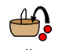 | To gather or take in information,
  Sharing 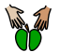 | Giving something to others
  Font 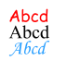 | The style of the letters and words you see on a screen or in a document.
  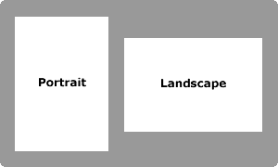 | When a page or screen is wider than it is tall.
   | When a page or screen is taller than it is wide.
  Orientation (see above) | The way a page or screen is turned — landscape or portrait.
  Placeholder | A space in a document where you can add something later, like a picture or text.
  Layout 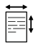 | How things are arranged on a page, like where the pictures and words go.
  Template  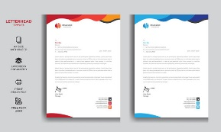 | A ready-made design you can use to help you make something, like a poster or leaflet.
  desktop publishing  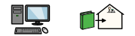 | Using a computer to make things like posters, leaflets, or cards with pictures and text.

