Year 6 – Geography – Globalisation and trade.
What should I already know? | What am I going to learn in this unit? | Vocabulary I need to know
- I know that globalisation is the world becoming more connected for different purposes through local, national and international trade.  - I know what types of transport have been important to globalisation and describe how this has changed over time for local national and international trading.  - I can explain what trade was like in the past for local national and international trading.  - I can explain how trade has changed over the years.  - I know some advantages and disadvantages of trading.  - I know what fast fashion is.  - I know that everyday clothes I wear come from all over the world and can give examples of this.  - I know what a multi-national company is and the advantages and disadvantages are of these.  - I know where the food I eat comes from and why this is imported and not home grown. | - I understand that products are made all over the world.  - I can describe why trade is important to the UK  - I can explain what trade, product, import and export are.  - I can define and reason what a supply chain is.  - I can explain what the 6 elements of the supply chain are.  - I can discuss who the UK trades with  - I can describe what the UK exports.  - I can explain human and physical resources.  - I can research different export amounts for different countries.  - I can explain what fair trade is  - I cand escribe how money is distributed amongst the different people within a supply chain. | Globalisation 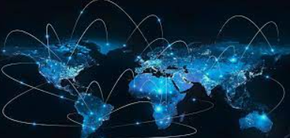 Is the way that things are done around the world together. This includes economics, trade, technology, politics or culture.  Trade 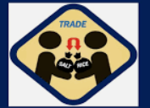 The buying or selling of goods and services.  Local 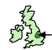 Within a small area or region, usually a part of a country.  National 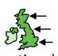 Within a country.  International 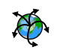 All around the world.  Port Place where boats can come and go to load and unload their supplies or people.  Container A metal box that is used to transport goods all around the globe.

