Year 6 Computing Spring 2
What should I already know? | What am I going to learn in this unit? | Vocabulary I need to know
- I know that some apps have permissions  - I can explain what app permissions are  - I can give examples of app permissions from apps I use  - I know privacy on apps can be increased  - I can explain how to increase privacy on apps  - I know how to adjust privacy settings  - I can explain why privacy settings are required  - I know there are a variety of applications to use in technology  - I can select a specific application to demonstrate learning  - I can format text to suit a purpose  - I can publish documents to suit audience and purpose  - I can design and write a programme for a specific outcome  - I can use a variable that I have created in a game | Digital Literacy:  - I know what online media is  - I know that online media can be used to influence  - I know how online media can shape our ideas about identity  - I know the meaning of gender messages  - I know online media can be used to shape ideas of gender messages  Information Technology:  - I can create a video using my skills of sound and effective features  - I can use green screen technology  - I can use green screen technology to mask a video  - I can use spreadsheets to input data  - I can write a formula in a spreadsheet  - I can write a formula to solve maths challenges  - I can present data in a spreadsheet | Influence the power to have an important effect on someone or something.  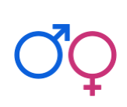 Gender Gender is the state of being male or female in relation to the social and cultural roles  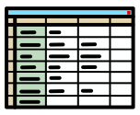 Spreadsheet represents information in a grid of rows and columns  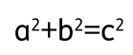 Formula a fact or a rule written with mathematical symbols.  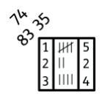 Data units of information

