Year 6 Science – Evolution & Inheritance - Spring 1 & 2
What should I already know? | What am I going to learn in this unit? | Vocabulary I need to know
- Make connections between the features of their family and other families.  - Notice differences between people.  - Begin to understand the need to respect and care for the natural environment and all living things.  - Notice that animals, including humans, have offspring which grow into adults.  - Recognise that environments can change and that this can sometimes pose dangers to living things.  - Describe the life process of reproduction in some plants and animals. | - I can recognise that living things have changed over time and that fossils provide information about living things that inhabited the Earth millions of years ago  - I can recognise that living things produce offspring of the same kind, but normally offspring vary and are not identical to their parents  - I can identify how animals and plants are adapted to suit their environment in different ways and that adaptation may lead to evolution  - I understand how Charles Darwin and Alfred Wallace developed their ideas on evolution  - I understand how living things on earth have changed over time.  - I can recognise that characteristics are passed from parents to their offspring  - I can observe and raise questions about local animals and how they have adapted to their environment  - I can compare how some living things have adapted to survive in extreme conditions  - I can analyse advantages and disadvantages of specific adaptations | Fossils  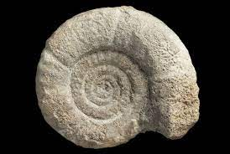 | The remains or impression of a prehistoric plant or animal embedded in rock and preserved in petrified form.
 |  | Adaptation  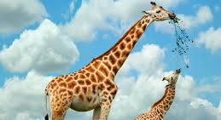 | The process of change by which an organism or species becomes better suited to its environment.
 |  | Evolution  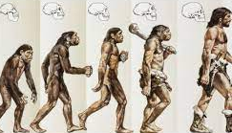 | The process by which different kinds of living organism are believed to have developed from earlier forms during the history of the earth.
 |  | Inherited  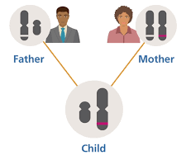 | A quality, characteristic, or predisposition derived genetically from one's parents or ancestors.
 |  | Characteristics  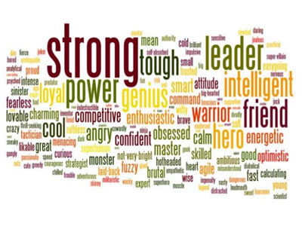 | A feature or quality belonging typically to a person, place, or thing and serving to identify them.

