Year 5 – Art – Using Sketchbooks
What should I already know? | What am I going to learn in this unit? | Vocabulary I need to know
- I know how to compare the work of different artists.  - I know how to identify the techniques used by different artists.  - I know how to explain some of the features of art from historical periods.  - I can identify the media used by an artist.  - I can make thoughtful observations about a piece of art.  - I can use some elements of the artist or genre. | - I know that differing depths of tone can be created with increasing pressure and higher pencil numbers.  - I know that I can use differing marks and lines to create an illusion of texture.  - I know that I can use smudging to soften harsh lines.  - I can use different shading skills to show mood and feeling and say why I chose those tones.  - I can choose specific imagery to convey a mood and say why I chose those images.  - I can explain how different media can be used to convey different emotion in art.  - I can use the same media in different ways to convey different feelings.  - I can alter an image using online tools to use in a new piece of art. | Manipulate To manipulate is to change or model by careful use of the hands; to manage shapes and forms in a space, less by additive or subtractive techniques than by moving things around.  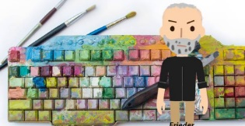 Digital Media Digital media refers to art made using software, computers, or other electronic devices. Anything produced or made on digital media, such as animations, photographs, illustrations, videos, digital paintings, and such can be classified as digital art.  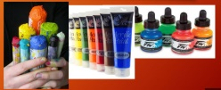 Wet Media Wet is any media that flows, or in other words, uses a liquid as pigment medium. Oil, watercolour, acrylic, and ink all fall into that category.  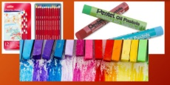 Dry Media Dry media includes but is not limited to graphite, charcoal, pastels, coloured pencils, chalk, and art crayons.  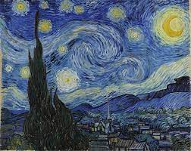 Representation Works of art that closely resemble forms in the natural world but is not a direct copy.  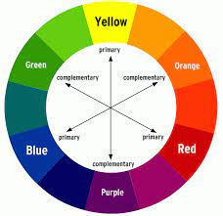 Complimentary Complementary colours are defined as colours that have maximum contrast for each other. The fundamental complementary pairs for painters are red/green, yellow/violet, and blue/orange.  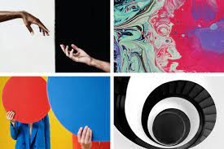 Contrasting Contrast art refers to the arrangement of opposite elements (light vs. dark colours, rough vs. smooth textures, large vs. small shapes  Symbolic Symbolist painters believed that art should reflect an emotion or idea rather than represent the natural world.  Atmosphere The way in which an artist uses colour and images in order to create as mood or feeling.

