Year 5 – French – Quelle est la date? – Spring 1
What should I already know? | What am I going to learn in this unit? | Vocabulary I need to know
- I know the vocabulary from the Early learning units  - I can say ‘Hello’ in French  - I can ask someone, ‘Do you have a pet?’ in French  - I can answer the question, ‘Do you have a pet?’ in French  - I can count to twenty in French  - I can read and recognise the nouns for pets in French  - I can write simple phrases and sentences about pets in French  - I can use simple connectives in my speech in French | - I can recall from memory the seven days of the week, the twelve months of the year and numbers one to thirty one, in French  - I can ask and answer the question, ‘What is the date?’ in French  - I can formulate the date, using days of the week, months of the year and numbers one to thirty one in French  - I can say when my birthday is using months of the year and numbers one to thirty one  - I know the French noun for ‘today’ | 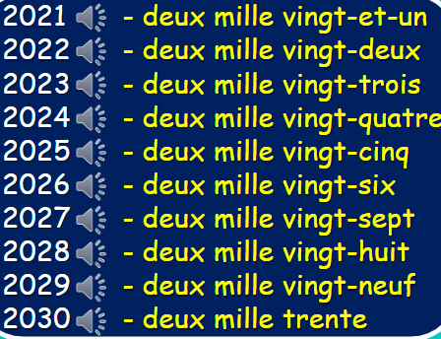  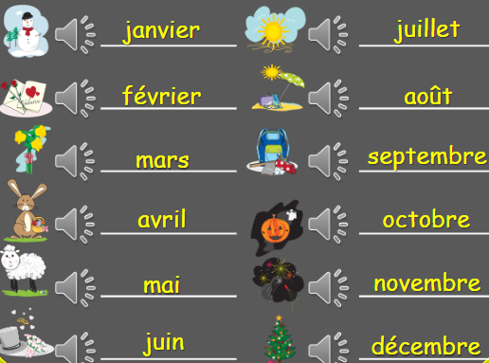  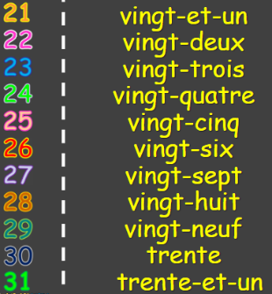  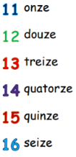  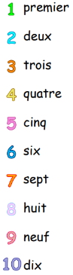  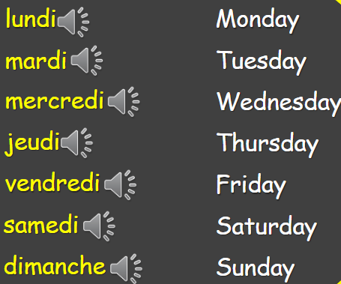  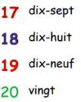  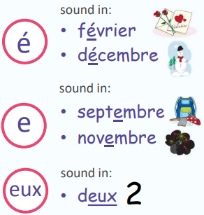  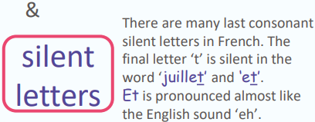  C’est quand ton anniversaire?  /Quelle est la date de ton anniversaire?  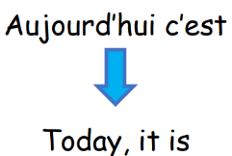  Mon anniversaire est le …

