Year 5 Science – Animals (Growing up and Puberty) Spring 2
What should I already know? | What am I going to learn in this unit? | Vocabulary I need to know
- I can understand the life cycle of different living things including mammals, amphibians and insects.  - I can understand the similarities and differences between these life cycles.  - I can understand the process of reproduction in animals.  - I can understand the process of reproduction in plants.  - I can research animal behaviourists and naturalists  - I can understand the difference between sexual and asexual reproduction in plants  - I can understand the term sexual reproduction in animals  - ‘I can observe and compare the life cycle of plants and animals  - I can record information using scientific diagrams and labels  - I can sort scientific evidence that has been used to support or refute ideas. | - I can describe the changes as humans develop to old age  - I can draw a timeline to indicate stages in the growth and development in humans  - I can understand the changes experienced in puberty  - I can research the gestation periods of other animals  - I can compare the gestation periods of other animals and humans | Growth | The process of increasing in size
 |  | Gestation  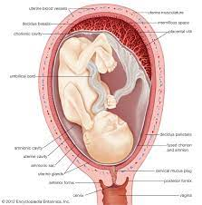 | The process or period of developing inside the womb between conception and birth
 |  | Puberty  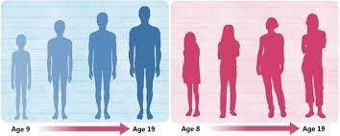 | The period during which adolescents reach sexual maturity and become capable of reproduction
 |  | Life Expectancy | The average period that a person may expect to live
 |  | Change  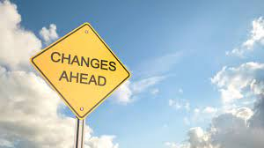 | Something that is different, altered or modified

