Year 5 – History – Ancient Greeks
What should I already know? | What am I going to learn in this unit? | Vocabulary I need to know
- I can accurately place civilisations in chronological order and state where they overlap.  - I can explain when and where the early Islamic civilisation developed.  - I can give reasons for why Baghdad became a major world power.  - I can explain what the House of Wisdom was.  - I can give examples of different areas of science and inventions that advanced during this time.  - I can name some important Islamic scholars.  - I can give examples of significant inventions during this time.  - I can explain what impact the inventions during this time had on our modern society.  - I can compare the similarities and differences between the Early Islamic Civilisation and Britain at the same time. | - I can give examples of reliable evidence sources that historians and archaeologists use to learn about an Ancient Civilisation.  - I can explain how the physical geography of Greece impacted the way the Ancient Greek civilisation developed.  - I can explain why historians have to use a ‘most likely’ approach when interpreting visual sources (pots) from Ancient Greece.  - I can give examples of what a primary source is and explain why these sources are usually a ‘reliable’ source.  - I can interpret evidence from a primary source and interpret a ‘most likely’ answer about what this source is telling us.  - I can explain the main characteristics of everyday life in Ancient Athens.  - I can explain the main characteristics of everyday life in Ancient Sparta.  - I can give examples of similarities and differences in how the Ancient Athenians and Ancient Spartans lived.  - I can use my research and evidence that I have gathered to explain my historical opinion.  - I can explain three different ways the Ancient Greeks changed the world.  - I can name three different concepts, ideas or inventions that came from Ancient Greece  - I can use my knowledge to suggest how the world might be different today if the Ancient Greeks legacy was different. | Civilisation People living together in large groups with a social structure.  Interpretation Looking for clues in a source to help explain what it tells us about life at that time.  Reliable Whether a source can be trusted to tell the truth about life at that time.  Democracy A fair system where everyone gets a chance to vote on an idea or choose a leader.  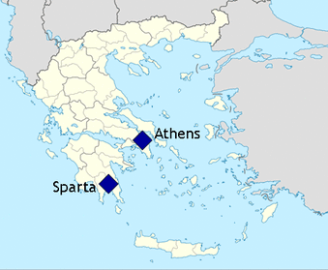
d

