Year 4 – Geography – Volcanoes and Earthquakes
What should I already know? | What am I going to learn in this unit? | Vocabulary I need to know
- I can explain the different climates in Europe and locate them on a map.  - I can interpret a simple climatic map.  - I can explain describe where the equator, Tropic of Cancer are in relation to European climates.  - I can explain the difference between grown, reared, and processed foods.  - I can explain what import, export, and trade means.  - I can give examples of food that are imported to the UK from Europe.  - I can explain why countries would choose to trade certain food rather than grow their own.  - I can give examples of human geographical features that might impact food distribution.  - I can give examples of physical geographical features that might impact food distribution.  - I can present my findings about European food distribution using Power point. | - I can explain the structure of the earth.  - I can explain what a tectonic plate is and how they link across the globe.  - I can explain the 3 different ways that plates move.  - I can explain that plate tectonics take millions of years to move and are constantly moving.  - I can explain the 5 features of an earthquake.  - I know where some of the deadliest earthquakes have taken place.  - I can explain that volcanoes can be active, dormant or extinct.  - I can explain the 5 deadly features of a volcanic eruption.  - I can explain why some people want to live near active and dormant volcanoes. | Earth 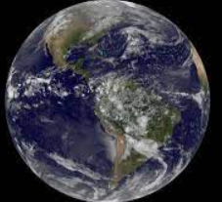 The planet in which we live on. Covered by more water than land.  Core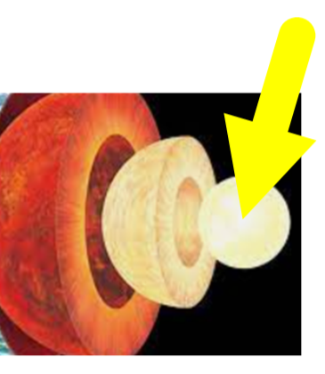 The centre of the earth. Made up of the metal Iron.  Crust 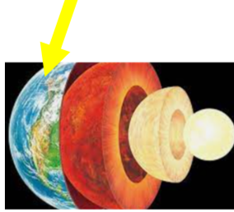 The crust is the thin layer around the earth. There are two types Oceanic crust and Continental crust.  Mantle 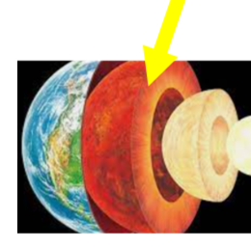 The outer mantle is the widest part of the earth. It is made up of semi melted rock called magma.  Plate tectonic 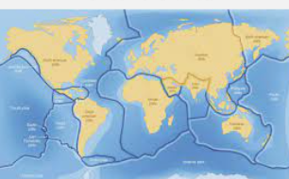 The crust is split into different rocky sections which fit together like a jigsaw.  Magma 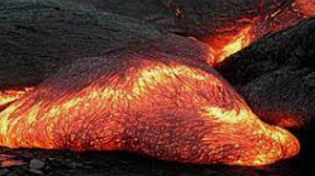 Hot liquified rock below the earths crust.

