Year 4 Science – Sound -Spring 2
What should I already know? | What am I going to learn in this unit? | Vocabulary I need to know
- Describe what they see, hear and feel whilst outside  - Explore how things work  - Identify, name, draw and label the basic parts of the human body and say which part of the body is associated with each sense | - I can identify how sounds are made, associating some of them with something vibrating  - I can recognise that vibrations from sounds travel through a medium to the ear  - I can find patterns between the pitch of a sound and features of the object that produced it  - I can find patterns between the volume of a sound and the strength of the vibrations that produced it  - I can recognise that sounds get fainter as the distance from the sound source increases  - I can explore the way sound is made through vibration in a range of different musical instruments from around the world  - I can investigate a variety of materials to see which provides the best insulation against sound | Vibration  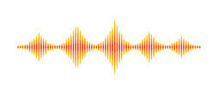 | Moving continuously or rapidly to and fro
 |  | Pitch  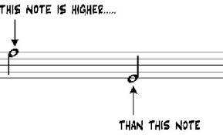 | The quality of sound which depends on the rate of vibrations e.g. the degree of highness or lowness of a tone
 |  | Sound | Vibrations that travel through the air or another medium and can be heard when they reach a person or animal’s ear
 |  | Insulation  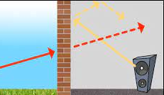 | Protect something by using material that prevents the intrusion of sound
 |  | Volume  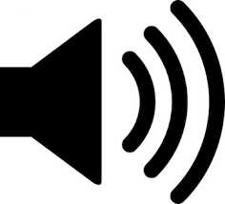 | The quality or power of sound
 |  | Dynamics | The varying levels of volume of sound in different parts of a performance

