Year 4 – Music Spring Ukulele
What should I already know? | What am I going to learn in this unit? | Vocabulary I need to know
- I know how to hold my own part in a round and am getting more confident with that skill  - I understand the difference between a crotchet, minim and a paired quaver  - I know the basic elements of music like dynamics and tempo  - I understand how notation works and can read two or three notes on the treble clef  - I can explain what a Pentatonic scale is and how to play it on a tuned percussion instrument | - I can sing rounds, partner songs and songs in unison  - I know the rhythmic notes minim, crotchet, crotchet rest and paired quavers  - I can follow and perform simply rhythmic scores to a steady beat  - I know the difference between major and minor chords  - I can play the ukulele demonstrating a basic skill  - I can accompany songs using basic chords (C major, F major, A minor)  - I can play and perform melodies following simple tablature (The Journey Begins and Pineapple) | 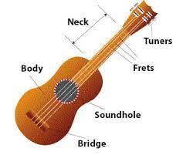 Neck The long thin bit of the Ukulele which we hold in our left hand  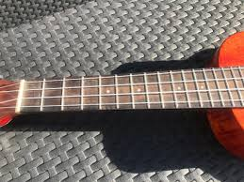 Fret The little gold lines down the neck of the Ukulele that divides the notes of the string up  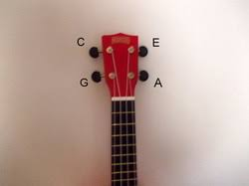 Tuning Peg The twisty knobs at the end of the neck that tighten or loosen the strings to tune them to the correct pitch  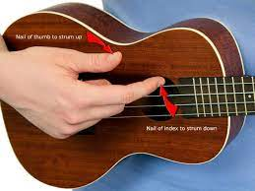 Strum To strike all the strings on the Ukulele at the same time to create the sound of a chord  Open string Play the string of a Ukulele without pressing the left-hand finger on any fret  Major Chord Three notes together that sound generally bright and happy  Minor Chord Three notes together that sound sad or mysterious

