Year 4 – French – Quelle est la date? – Spring 2
What should I already know? | What am I going to learn in this unit? | Vocabulary I need to know
- I know the vocabulary from the Early learning units  - I can say ‘Hello’ in French  - I can ask someone questions about themselves including their age in French  - I can answer questions about myself, including my age in French  - I can count to twenty in French  - I can read and recognise the nouns from the Goldilocks story in French  - I can read and write phrases from the Goldilocks story in French | - I can recall from memory the seven days of the week, the twelve months of the year and numbers one to thirty one, in French  - I can ask and answer the question, ‘What is the date?’ in French  - I can formulate the date, using days of the week, months of the year and numbers one to thirty one in French  - I can say when my birthday is using months of the year and numbers one to thirty one  - I know the French noun for ‘today’ | 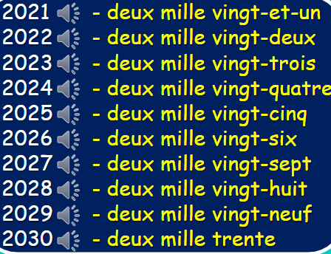  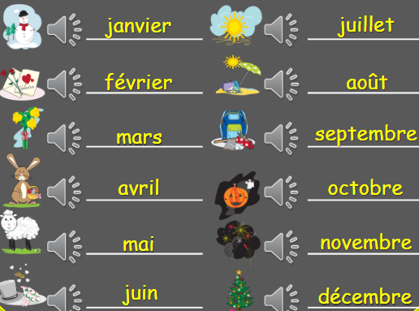  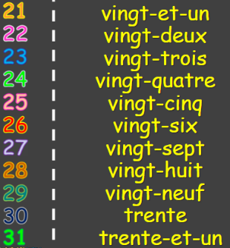  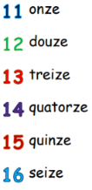  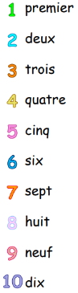  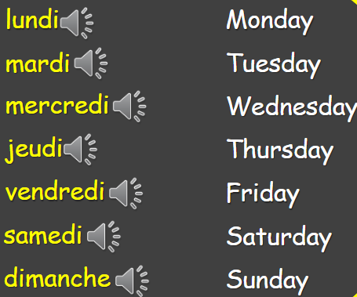  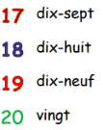  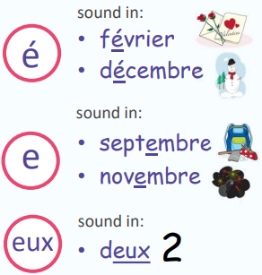  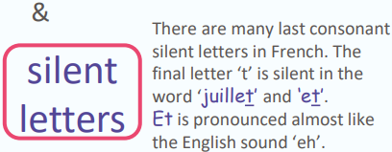  C’est quand ton anniversaire?  /Quelle est la date de ton anniversaire?  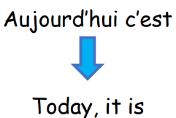  Mon anniversaire est le …

