Year 4 – Design and Technology – Food Technology – Food Swaps
What should I already know? | What am I going to learn in this unit? | Vocabulary I need to know
- (From Year 3)  - I know that climate affects food growth  - I know that each fruit and vegetable give us nutritional benefits.  - I can explain which foods are healthy.  - I can explain which foods are less healthy.  - I know when food is nearly ready for harvesting.  - I know how to be hygienic when preparing and handling food.  - I know how to stay safe whilst preparing food. | - I can explain what a balanced diet is.  - I can explain the difference between savoury and sweet.  - I can research recipes and understand how to read if they are healthy or not.  - I can suggest ‘swaps’ to make an unhealthy food healthier.  - I can explain how chefs such as Jamie Oliver have campaigned to make food for children healthier.  - I can plan my ‘swaps’ recipe.  - I can prepare my recipe safely using the right equipment.  - I can ask questions to evaluate the taste, appearance and texture of my food.  - I can improve my recipe based on feedback.  - I can read a food label and explain whether it is healthy choice or not.  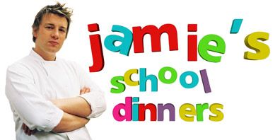 | Balanced diet Making sure we eat more of the links that are good for us and less of the things that aren’t.  Savoury Food that isn’t sweet but more salty or spicy like pasta, brown bread, cheese or chilli.  Ingredient The different food you need to make something like a meal or to bake bread.  Recipe The list and instructions to help you make different foods and meals.  Food swap When you change an ingredient to make it healthier or to change it.  Evaluate When you look at a product and decide what was good about it and what you would make better next time.  5 Senses Sight Touch Taste Smell Sound

