Year 3 Spring 2 Art – Using Sketchbooks
What should I already know? | What am I going to learn in this unit? | Vocabulary I need to know
- I know how to compare the work of different artists.  - I know how to identify the techniques used by different artists.  - I can identify the historical art and cultural significance of specific artists.  - I can begin to identify the media used by an artist.  - I can say what I like and dislike about a piece of art.  I can begin to use some elements of the artist or genre. | - I can use the proportions to sketch realistic facial features.  - I can identify the different features in a range of facial expressions.  - I can use lines and shading to replicate facial expressions.  - I know how to integrate digital images into artwork.  - I can use images that are available online and incorporate them into new art.  - I know how to use sketching to produce a final piece in art.  - I can review my work, saying what I like think has been effective and what needs to improve.  - I can review the work of others, saying what I like and what needs to improve. | 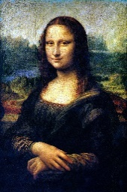 Portrait A picture of a person usually showing the face. Also used for the orientation of a piece of art – portrait orientation is taller than wider.  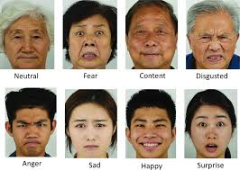 Expression A look on someone's face that conveys a particular emotion.  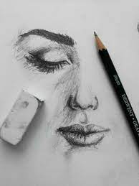 Sketching A drawing representing the chief features of an object or scene.  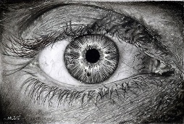 Realistic Realistic art refers to accurate and detailed depictions of life.  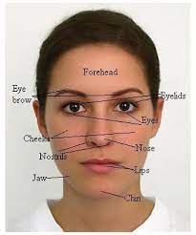 Features A distinguishing element of a face, such as an eye, nose, or lips.

