Year 3 Computing Spring 2
What should I already know? | What am I going to learn in this unit? | Vocabulary I need to know
- I know what personal information is  - I know what personal information can be shared safely  - I know who I can trust to share personal information with online  - I know that the web is made up of a collection of websites  - I know how to use a search engine to navigate the web  - I can use the web to collect information and media  - I can use a range of programmes to present information  - I can use a range of functions to present information  - I can save my work  - I know that commands are a language used in computing  - I know how to use command blocks to complete a task  - I can build command blocks  - I can use command blocks in a sequence  - I can create command blocks that can connect | Digital Literacy:  - I know what an avatar is.  - I know that an avatar can represent me online.  - I know that an avatar can be changed for different reasons.  - I know what avatars can represent.  - I know when to use an avatar.  Computer Science:  - I know that an algorithm is a set of instructions.  - I know that an algorithm can be made up of command blocks.  - I can write an algorithm using command blocks.  - I can implement my algorithm into a coding programme.  - I can write an algorithm to achieve an intended goal.  - I can write an algorithm that includes directional movement. | avatar a graphical representation of a user or the user's persona  represent to speak, act, or be present officially for another person or people  persona the personality that a person projects in public  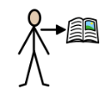 character a person, animal, or object/thing  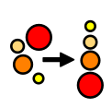 sequence a set of related events, movements or items that follow each other in a particular order  command being told to do something  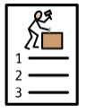 implement putting a decision or plan into effect  evaluate Judging your own design or product

