Year 3 – History – Roman Invasion
What should I already know? | What am I going to learn in this unit? | Vocabulary I need to know
- I can sequence the Neolithic, Bronze and Iron ages and I know how long they lasted.  - I can tell you about weapons, agriculture, settlements and rituals within the Neolithic, Bronze and Iron Ages.  - I can sequence artefacts from different time periods.  - I understand and can explain the passing of time.  - I can compare changes in history (weapons, agricultures, settlements and rituals).  - I can give opinions using historical evidence.  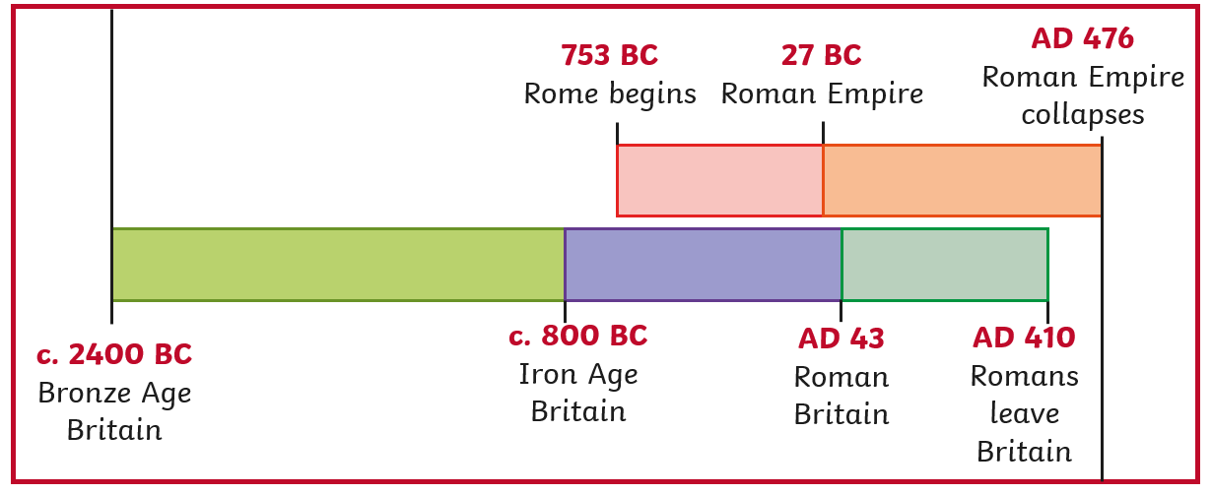 | - I can explain the key developments during the Iron Age.  - I can explain the difference between BC and AD.  - I can give reasons about why the Romans invaded Britain.  - I can explain the difference between an invasion and a battle.  - I can give details about three Roman Invasions of Britannica ( BC55, BC54 – Julius Caesar and AD 43- Claudius).  - I know that the Romans ruled Britain between 43 AD and 410 AD.  - I can explain the key characteristics of life in Britain during the Roman era.  - I can explain the different responses to the Roman invasion including the Picts and Boudicca rebellion.  - I can explain the impact of the Roman invasion on Britain. | BC and AD 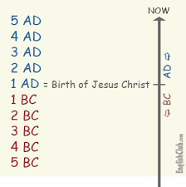 BC are the years before Jesus was born and AD are the years after he died  Invasion People who come to another land to attack, take resources and take charge  Settlers People who move and create a new place to live.  Characteristics The important things that make a person or place what they are.  continuity Staying the same  change Not staying the same  Picts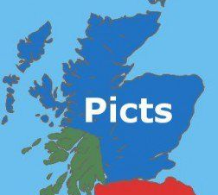 A tribe that lived in the North of Britannica  Boudicca A rebel leader who fought against the Romans  Celts 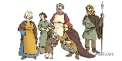 The tribes already living in Britannica before the Romans came.  significance The most important thing.  Impact How much an action changes things around them.  Defence Protecting yourself against others attacking you.

