Year 3 Science – Light -Spring 2
What should I already know? | What am I going to learn in this unit? | Vocabulary I need to know
- Explore how things work  - Talk about the differences in materials and the changes that I notice  - Describe what I can see, hear, and feel when I’m outside  - Describe the simple physical properties of a variety of everyday materials | - I can recognise that I need light in order to see things and that dark is the absence of light.  - I can notice that light is reflected from surfaces.  - I can recognise that light from the sun can be dangerous and there are ways to protect my eyes  - I can recognise that shadows are formed when the light from a light source is blocked by an opaque object.  - I can find patterns in the way that the size of shadows change.  - I can explore what happens when light reflects off a mirror or other reflective surfaces  - I can research what might cause shadows to change | Light Source  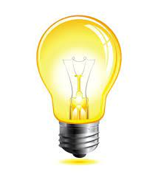 | An object that makes its own light.
 |  | Reflection | The process where light hits the surface of an object and bounces back into our eyes.
 |  | Ray  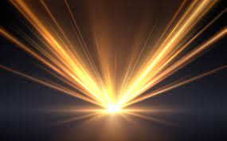 | Waves of light are called light rays. They can also be called beams.
 |  | Shadow  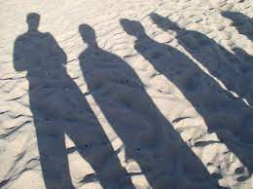 | An area of darkness where light has been blocked
 |  | Translucent | Describes objects that let some light through, but scatter the light so we can’t see through them properly
 |  | Opaque | Describes objects that do not let any light pass through them

