Year 3 – French – Petit Chaperon rouge – Spring 2
What should I already know? | What am I going to learn in this unit? | Vocabulary I need to know
- I know the letter sounds (phonics and phonemes) from phonics and pronunciation lesson 1.  - I know the vocabulary from the ‘J’apprends le français’ unit  - I know the vocabulary from units ‘Les instruments’ and ‘Les saisons’ | - I can sit and listen to a familiar story being told in French  - I can use picture and word cards to recognise new language and help me to retain the new language in French  - I can recall key vocabulary and phrases from the story ‘Petit Chaperon Rouge’ in French | 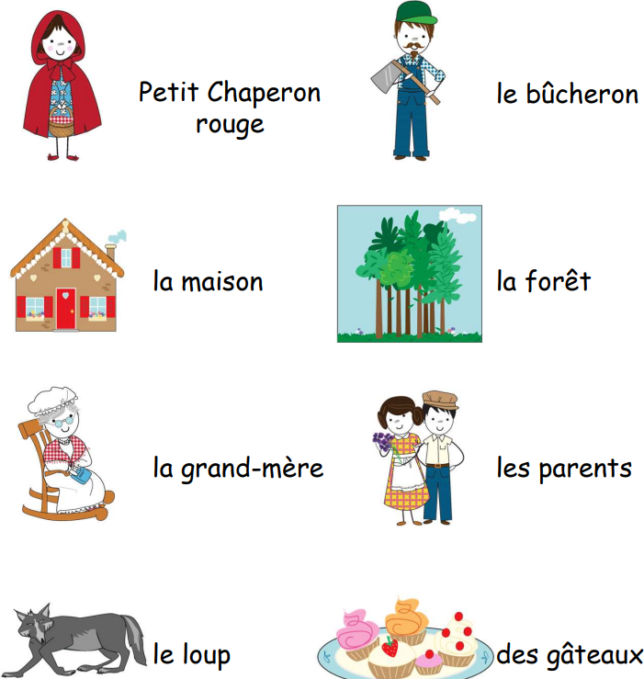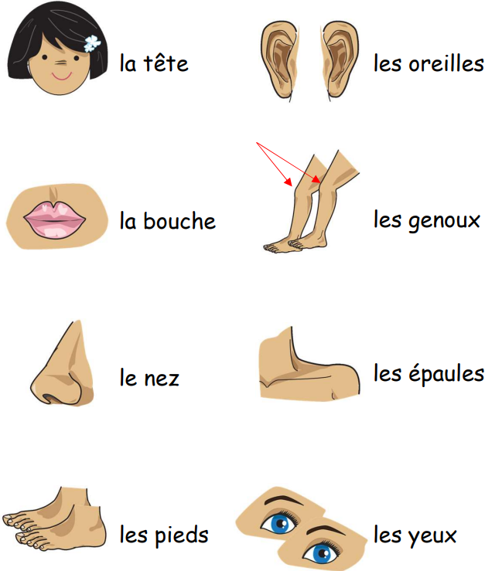  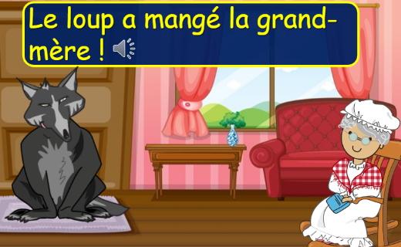  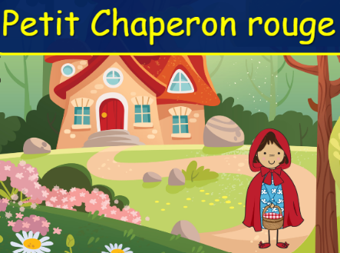  Once upon a time  All the better to see you! All the better to hear you! All the better to eat you!

