Year 3 – RE- Symbol- Christianity
What should I already know? | What am I going to learn in this unit? | Vocabulary I need to know
- I can give an example of how a given concept is shown within a religion.  - I can acknowledge that some ideas are hard to explain.  - I can begin to reflect on important issues and talk about my feelings.  - I can identify some symbols that are seen in everyday life.  - I can explain the basic elements of the Easter Story (Year 1 and 2).  - I can identify some logos and explain their meaning from my own experiences.  - I can understand, explain and give some examples of the concept of ‘Imagery’ (Year 3) | Inquire  - I can explain that symbols can have a different meaning/ value depending on the symbol using examples to explain my answer.  - I can identify and provide an example of how a symbol is different to a sign.  Contextualise  - I can give examples of how the cross is symbolic for Christian’s.  - I can identify how two different crosses can have a different meaning. I can explain why this is drawing on my knowledge from the Easter story.  Evaluate  - I can give an example as to why the concept of symbol is important to a person of faith. I can say whether I agree or disagree.  - I can express my own views of the importance of symbol to Christians and explain my answer with an example.  Communicate  - I can give an example of what I would consider to be important in my life and develop a symbol around it.  - I can give opinions as to what I think makes an effective symbol and the meaning behind it.  Apply  - I can describe simple examples of how their response to concept of symbol relates to their own lives and those of others.  - I can identify some differences the concept of symbol makes to the lives of religious people and myself. | Resurrection 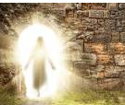 The rising of Jesus from the dead to new life.  Forgiveness 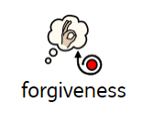 The action or process of forgiving or being forgiven.  Disciples 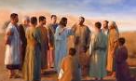 Followers of Jesus during his life on Earth.  Stations of the Cross 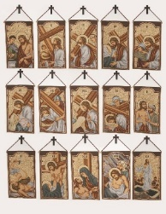 A series of images showing Jesus on the day of his crucifixion.  Salvation The act of delivering (or keeping away) from evil and saving from sin. Being saved.  Crucifixion 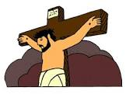 A method of punishment where someone is nailed to a cross to die. .

