Year 4 – RE- Symbol- Christianity- Golden Thread Belonging
What should I already know? | What am I going to learn in this unit? | Vocabulary I need to know
- I can give an example of how a given concept is shown within a religion.  - I can acknowledge that some ideas are hard to explain.  - I can begin to reflect on important issues and talk about my feelings.  - I can identify some symbols that are seen in everyday life.  - I can explain what the concept of symbol means in the context of the symbol of the Cross (Year 3).  - I can recall the main elements of the Easter Story and identify its importance to Christians (Year 3).  - I can explain the meaning of the concept of Ceremony and give some examples (Year 3). | Inquire  - I can explain clearly, in simple terms, the concept of symbol and how this is common to all people.  - I can identify and provide an example of how a symbol is different to a sign.  Contextualise  - I can explain and describe what the eucharist is and it’s meaning to Christians.  - I can identify and explain how Christian’s use the concept of symbols when they share the eucharist.  Evaluate  - I can recognise and describe accurately why the symbols of bread and wine are important to Christians.  - I can explain why replacing the symbols of bread and wine with other items will not have the same meaning or importance to Christians.  Communicate  - I can give an example of the concept of symbol in my own life and express what it means to me.  - I can give opinions as to why symbols are important in my life and the lives of others.  Apply  - I can explain their emotional response/ feelings I have about their own symbol with examples.  - I can explain how their symbol/ understanding of the concept of symbol affects their own and others’ lives. | Forgiveness 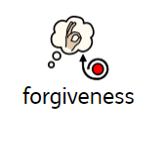 The action or process of forgiving or being forgiven.  Communion 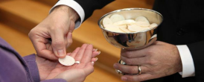 Communion means, simply, 'togetherness' and this is a ritual to show the togetherness of Christians and God. This is where Christian’s share the bread and wine of communion.  Resurrection The act of coming back to life after death.  Salvation The saving of a person from sin or evil.  The Last Supper 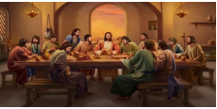 The Last Supper is the final meal that, in the Gospel accounts, Jesus shared with his apostles in Jerusalem before his crucifixion  Crucifixion 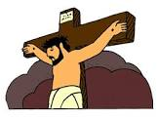 A method of punishment where someone is nailed to a cross to die

