PSHE Year 4 Unit Plan – Spring two
Sticky Knowledge:
Relationships:
- I can explain the difference between playful dares and dares which put someone at risk.
- I can identify how to manage pressures associated with dares.
- I can explain how to report my concerns and seek help if I am worried or uncomfortable about someone’s behaviour, including online.

Living in the wider world:
- I can explain what digital footprint means.
- I can recognise that everyone has a digital footprint.
- I can explain what online data is.
- I explain how online data is shared and used.
- I can explain how to recognise factual content.

Health and wellbeing:
- I can recognise what is meant by a ‘drug’.
- I can identify some of the effects related to different drugs and that all drugs, including medicines, may have side effects.
- I can recognise that for some people using drugs can become a habit which is difficult to break.
Safeguarding:
- I can identify how to manage pressures associated with dares.
- I can explain how to report my concerns and seek help if I am worried or uncomfortable about someone’s behaviour, including online.
- I can explain what digital footprint means.
- I can explain how to recognise factual content.
- I can recognise that for some people using drugs can become a habit which is difficult to break.

Objective | Retrieval and Revisit | Teaching and Modelling | Independent Application | Vocabulary
Concept: Safe relationships  LO: I am learning how to recognise risks (including online) and how to seek help  Sticky knowledge A B C  Safeguarding A B | Pick key vocab from last unit plan.  Chn to have a multiple choice answer quiz on the key vocab. | Baseline: Confidence scale  Give the children a selection of playful dares to have a go at. After, discuss some dares that could potentially be more harmful. Discuss why, what could they lead to etc. Ensure the dares include online.  Create a scenario which involves a character considering whether to participate in a slight risk. Unpick together the risk, discuss the pressure they may be feeling and who they could talk to if they are concerned.  If time, create a poster giving their top tips for risks/dares and how to seek help.  Ask-it basket & baseline. | Chn to rate their confidence on the following statements:  I understand what a dare is.  I understand what a risk is.  I know how to assess the risk of a dare.  I know who to speak to if I am worried.  As a group, chn to discuss different dares and sort them into a continuum of level of risk. Allow class to then gallery walk, looking at other groups’ continuums.  Chn to then have a go at a different scenario, identifying the risk, pressure and giving them advice in their books.  Potential scaffold:  Multiple choice responses. | Risk  Dare  Harm  Hazard  Safety  Online  In person  Peer  Pressure
Objective | Retrieval and Revisit | Teaching and Modelling | Independent Application | Vocabulary
Concept: Media literacy and digital resilience  LO: I am learning to understand that everyone has a digital footprint.  Sticky knowledge D E F  Safeguarding C | Rail safety:  Fill a whiteboard with as much as you can remember on how to stay safe near railways. | Baseline: Explain to an Alien – What is data?  Give each child a Post It note and ask everyone to write one (nice) thing about themselves on it – e.g. ‘my favourite pet is a dog’, ‘my favourite film is the BFG’ and stick it on their backs. Then ask them to move around the class reading each other’s Post It notes, trying to make sure that no one is quite sure who is reading what is on their backs at any given moment.  At the end of the exercise ask children to think about something they might not want to tell anyone. Ask them to imagine if that were on the Post It note. How would they feel? Explain that this is what it can be like using social media, so be very careful what they share. If they share this online, it will be become part of their digital footprint and that everyone has one. Clarify what online data is and explain what different types of data can help to build a digital footprint (text messages, internet searches etc.). Explain that the data we share can be used by companies who would like to encourage people to buy things.  Create a character which has some information about their searches/internet history – what can we tell about them? What is their digital footprint? Include a positive one and a negative one (someone who has sent mean messages, left rude comments). Who would be a better person to be friends with? Why? What would we want our digital footprint to tell someone about us? How do we create a positive footprint?  Ask-it basket & baseline activity. | Children to come back to this at the end of the lesson and edit with purple pen, now adding what they know about a digital footprint. Potential scaffold: widgits – which ones would they use to help explain?  Discuss a definition for digital footprint, discussing what is meant by data and why may companies want this information? How could they use this information?  Children to have a new positive character which they will have to list what they know about the person based on their digital footprint.  Potential scaffold – statements which they have to sort (include some that wouldn’t be true about the character).  Chn to then have a go at a different character with their internet history. What can you tell about that character?  Is it a positive or negative digital footprint?  Potential scaffold: multiple choice responses. | Data  Sharing  Online  Digital footprint  Advertisement  Internet searches  Search engines  Information  Trail
Objective | Retrieval and Revisit | Teaching and Modelling | Independent Application | Vocabulary
Concept: Media literacy and digital resilience  LO: I am learning how online data is shared and used.  Sticky knowledge G H  Safeguarding D | Chn to be given a description of a friendship and identify the positive qualities. Potential scaffold: Physically highlight the qualities.  Discuss afterwards an argument that is had between the friends. What advice would we give them to repair the relationship? (Verbal discussion) | Baseline: Before and after knowledge square.  Class discussion of how online information is shared (social media, apps, internet searches).  Show the children a range of different adverts. Then ask the children the following questions:  How did you feel when you watched it?  What did the advert do to make you feel like that?  Did it look like real life, or were some parts of it ‘pretend’?  In what ways is it the same/different from everyday life?  Ask children ‘What was the advert trying to encourage people to do?’ and invite them to suggest the purpose of each advert, for example to sell a product, share information, or influence behaviour (e.g. to be healthier or support a charity). Gather their examples of the different purposes of adverts on a flip-chart.  State that it’s OK to want to buy or use the things we see in adverts, and to want to look and feel good, but it’s important not to place too much importance on what we see in the media and in turn have unrealistic expectations of ourselves.  In small groups, provide different examples of online adverts and other content that is shared for factual purposes (e.g news article) and ask them to compare.  Baseline & ask-it basket | How is data shared?  Verbal discussion  Class flip-chart  Show altered adverts/photographs to help enforce this.  Small group work – take photo of group work for books, including a small slip explaining what the children have learned. | Online data  Digital footprint  Advertisement  Purpose  False advertisement  Information  Influence
Objective | Retrieval and Revisit | Teaching and Modelling | Independent Application | Vocabulary
Concept: Keeping safe  LO: I am learning to recognise drugs that are common to everyday life.  Sticky knowledge I J K  Safeguarding E | Provide a scenario of a character who is starting to show early signs of illness – can we identify what they are?  How should the character treat themselves? (medicine)  At what point in an illness should someone go to the doctor?  Potential scaffold:  Multiple choice answers | Baseline:  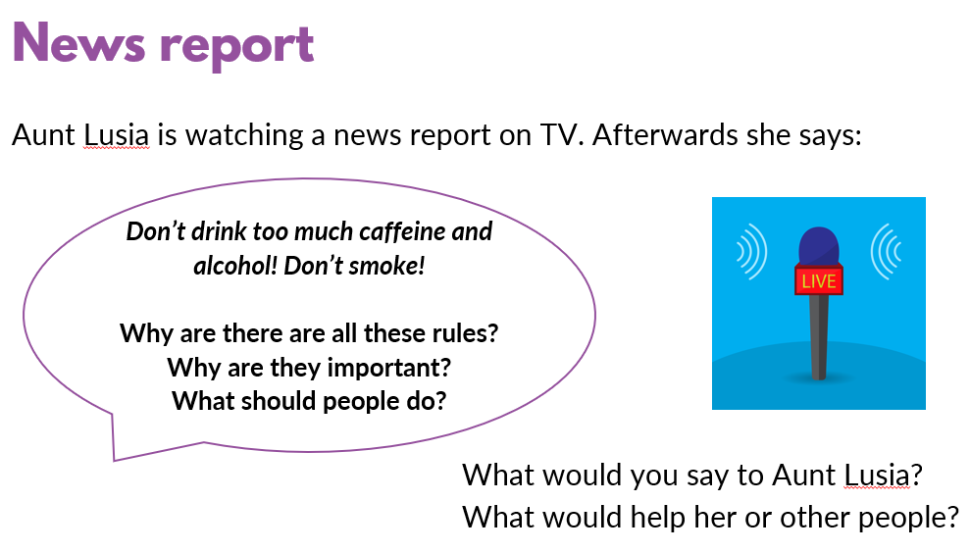  Premade slides – Yr3-4 Lesson 1 – Drug & alcohol education  The premade slides come with notes to help with the teaching of this topic. Please use these to support  Baseline & ask-it basket. | Chn to respond to questions. | Caffeine  Alcohol  Drugs  Common  Vaping  Smoking  Cigarette  E-cigarette  Risk  Addiction  Habit  Healthy  Unhealthy  Illness
Session and Objective | Retrieval and Revisit | Teaching and Modelling | Independent Application | Vocabulary
Consolidation lesson | The whole session is based on retrieval and revisiting | Revisit key information from each of the previous Los  Aim: Consolidate sticky knowledge, ensure that any missed learning is caught up.  If there are any children missing from this session, ensure that they did not miss the initial taught lesson either. If a child has missed both the initial lesson and the consolidation lesson then an intervention must be delivered, especially if it has safeguarding sticky knowledge. If a child has missed one of the sessions, use your AFL to decide if they will need an intervention.  Each LO in this unit plan needs a task, scaffolded appropriately. On each task, label sticky knowledge at the top (LO is not needed as well).  Discuss as a year group which sticky knowledge (if any) may need to more of a focus depending on the understanding of the children. Although all must be discussed, some may be much quicker and some may need further depth to ensure it is secure. | Appropriately scaffolded tasks to complete, minimum of one for each LO. | As above

