Year 5 (RE) Knowledge Organiser – Spring 2 Sacrifice
What should I already know? | What am I going to learn in this unit? | Vocabulary I need to know
- I can ask questions to understand the meaning of a concept in my own life and the lives of those around me.  - I can explain the difference that the concept makes to the lives of religious people and myself.  - I can explain the meaning of the concept of ‘Symbol’ (Year 3 and 4) and consider how this may link to the concept of Sacrifice in the Christian faith.  - I can explain the concept of ‘Temptation’ (Year 4) and identify how this might link to the concept of Sacrifice and link to the Easter Story.  - I can identify key elements of the Easter Story (Years 3 and 4) and explain why this is important to Christians. | Inquire  - I can share my own experiences of sacrifice and give examples as to how it makes me feel.  - I can explain what sacrifice means to myself and others.  Contextualise  - I can identify how sacrifice is a central part of the Christian faith.  - I can explain how and why Jesus is seen as having made a sacrifice within the Christian faith.  Evaluate  - I can explain the importance and relevance of sacrifice of Christians and provide examples within religious practice.  - I can express what the idea of Jesus’ sacrifice means to me and give reasons for my opinions.  Communicate  - I can explain some of the challenges I have faced with the idea of sacrifice in my own life as well as some positives.  - I can explain the importance of the concept of sacrifice to myself and those of the Christian faith. I can identify differences in opinions and express why this might be.  Apply  - I can describe how the concept of sacrifice can be applied in their own lives and the lives of others.  - I can identify the significance of the concept of sacrifice within world history | Salvation The saving of human beings from death and separation from God by Jesus’ death and resurrection.  Symbolism The use of symbols to represent ideas or qualities.  Martyr 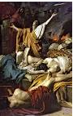 A person who is killed because of religious or other beliefs.  Communion 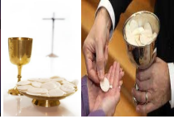 Christians take Holy Communion at Church (bread and wine) in remembrance of the body and blood of Jesus that was broken and poured at the cross.  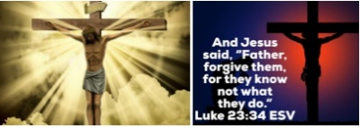 Stations of the Cross A series of images showing Jesus on the day of his crucifixion.

