Retrieval | Yr 5 objectives |  | Outcome
Last LJ:  - Prefixes  - Suffixes  - Subordinating clauses  - Relative clauses | - Using a range of vocabulary to entertain the reader  - Speech to enhance meaning and move on the action  - Writing in the past perfect and past progressive tense to enhance consistency and interest  - To build cohesion in my writing using:  - pronouns / nouns |  | Mythical narrative written in 3rd person using invented demi-God.
Retrieval | LO | Lessons activity | Outcome
 | I am exploring superheroes | - Show children slides of familiar superheroes  - Chn to think about their favourite superhero and what qualities they have  - Chn to create their own superhero and decide what their normal and super power qualities would be  - Read Chap 1 Percy Jackson | Characteristics of superheroes – normal v superpower
Ret: Percy Jackson Chap 1 | I can explore conventions of a mythical narrative | - Conventions of a mythical narrative  - Conventions wall  - In pairs read some examples and highlight conventions  - Come back to discuss which conventions have been found | Class list of features of mythical narratives
Ret – adverbs | I can write a sustained description of a character | Vocabulary Practice (Character )  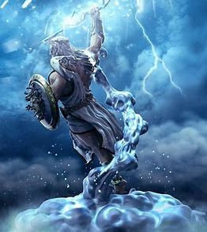  - Watch a video introducing the Greek Gods  - Write a simple (bad) description of Zeus. Why is it bad, what’s missing?  - ‘I do’: model choosing noun – e.g. shield, lightning bolt (what defines him) model writing a sustained description using expanded noun phrases and adverbs. Model i) choosing noun, ii) choosing adjectives to describe noun, iii) choosing verb (what is noun doing?) iv) choosing adverb.  - ‘We do’ show another picture of a different God – Apollo, Hermes, Athena  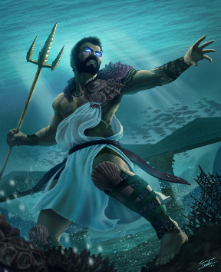  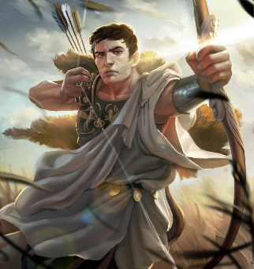  - ‘You do’ children to describe Poseidon – choose and image with plenty to describe – how the God appears, what is he doing – action shot. | Skills practice  - Impactful Images of Gods  - Print 30 x image of Poseidon  - Create sentence builder with Nouns, adjectives, verbs, adverbs – choose simple to more difficult to reasonably adjust.  - Print 30 x sentence builders
Ret – abstract nouns | I can write a sustained description of a setting | Vocab skills (setting)  Follow same format as above -model a simple (bad) description of an image – choose settings similar to where some of the Gods reside over e.g. Ares God of War, Poisidon, God of Sea. Use hook / image for children to apply own writing skills with lots of drama – e.g. a desolate valley in the darkness during lightning storm.  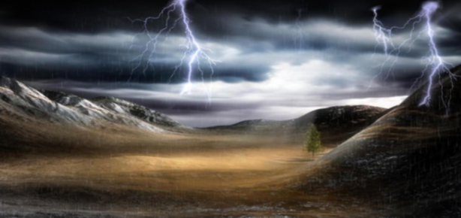 | Skills practice:  - Impactful Images  - Print 30 x image for apply  - Create sentence builder with Nouns, adjectives, verbs, adverbs – choose simple to more difficult to reasonably adjust.  - Print 30 x sentence builders
Ret – adjectives for Gods |  | Skills write – write a description of a chosen God  - Recap skills  - Model how to compose a setting and character description combined  - Maybe model how not to do it – what kind of atmosphere do you want to create?  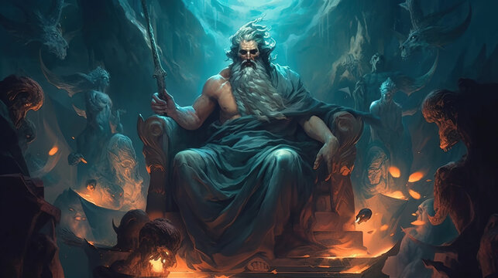 | Skills write:  - 30 x image of Hades  - Sentence builder  - WBs – widget word bank plus question prompt – use senses
Ret – Speech punctuation | I am learning how to use speech to move on the action in a story | Skill practice (dialogue to move on action )  Compare two models – WABOLL V WAGOLL – less is more, what’s more exciting? Events, revelations of characters, cliffhanger  - Drama – act out the scene  - Give chn full reign, then refine – you can only say 5 things, then 2 – what will they be?  Task: Write a dialogue summary of the scene they have acted out. What are the most important bits of speech | Skills practice:  Select dialogue from the book that best shows the LO  - 30 copies for group work  - Add prompt questions for WT  - Provide the characters and dialogue. Chn to add another bit of speech for WB
Ret – speech punctuation – correct the sentence |  | Skills write (move on action)  Recap previous skills – need to set scene  We do – watch clip – brain storm what happens next, allow chn time to write some dialogue, then collect ideas and flipchart.  You do  Give them different opening scene / setting – now add dialogue  WBs speech bubbles / or fill in blanks | Skills write  - Use video clip to predict what happens next then write dialogue.  - Speech bubbles
Ret – | To use a range of pronouns and nouns to avoid repetition and improve cohesion in paragraphs. | Use pronouns to enhance cohesion  (Writing session)  WABOLL v WAGOLL  What words will help them in their outcome  Pronouns for creature / beast, God /Goddess / hero /villain  Editing – give them a paragraph with a lot repeated and ask them to write it out again with pronouns to avoid repetition  WTs – highlight changes  WBs – Edit on sheet | Skills practice
Ret – sustained description using previous image |  | Tense (progressive and perfect)  Teach the past progressive using examples – send away to convert sentences into the past progressive  Teach past perfect – use a hook – image/video for children to write past perfect text relating to hook. | Skills practice  WBs to write simple sentences in past tense.
Ret - past progressive |  | Tense (progressive and perfect)  Diary entry – easier to write in past in first person, using past progressive, past perfect.  Recap past progressive and past perfect.  Ido – show chn text to identify examples of past progressive, past perfect  WBs write simple past tense using substitution table – adapt LO | Skills write  - Chn to write a diary entry as Percy using past progressive and past perfect about the bull chasing scene  - Sentence builder  - Video stills with example sentences  - WBs to write in oastr tense about Hippocampus video clip
Week 6 | Structure | Exploring mythical narrative - 1. structural features 2. Grammatical features
 | Structure | Model Text – analyse – mythical narrative – Thesius and the Minotaur
 | Plan | Plan story beginning / Write
 | Write | Plan story middle / write
 | Write | Plan story / write / edit
Purpose: To entertain
Audience: Peers
Form: Mythical narrative

