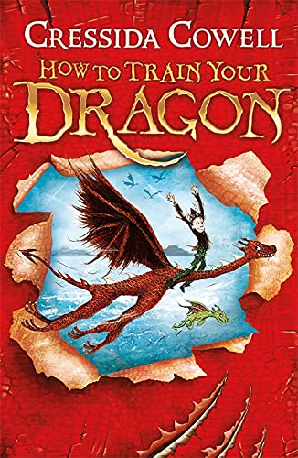

**Revisited Skills:**

* I can predict and infer
* I use nouns and pronouns to avoid repetition
* I can use similes and metaphors
* I can construct paragraphs around a theme
* I can edit and improve my writing

**New Skills:**

* I can use simple organisational devices (e.g. headings, subheadings and bullet points)
* I can understand formal vs nonformal language
* I can use technical language to convey information
* I can indicate possession by using the possessive apostrophes with singular and plural nouns

**Audience: Vikings who want to expand their knowledge of dragons**

**Form: Non-Chronological report**

**Purpose: To inform`**

**Tier 3 Vocabulary:**

**Fragile intricate**

**conjuror fury revenge**

**precarious**

**Tier 2 Vocabulary:**

**Prepositions construct**

**metaphor simile**

**Theme:** Different worlds

**Related texts:**

The Mapmakers – Tamzin Merchant

Illustrated Stories of Dragons – Usborne

Dragons at Crumbling Castle – Terry Pratchett