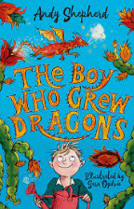

**Revisited Skills:**

* Adjectives to describe.
* To use the article a or an correctly.

**New Skills:**

* To select word choice to show characters personality.
* To investigate how rhyme and rhythm create effect within a poem.
* To use prefixes anti -, re-, inter-, super-,

**Audience: Year 3 children**

**Form: Poem**

**Purpose: To entertain**

**Tier 3 Vocabulary:**

**Tendrils, bioluminescence, supersonic, detonation, kaleidoscope**

**Tier 2 Vocabulary:**

**Scorch, expert, explode, incident, blazing, fizzle, flame, claws, scales, spark, reptile, pulp, glimmer, bulge, spike, flutter, ignite, sprout, interact, anticipate, supervise, superpower, recover, react, rebuild**

**Theme:** Adventure and magic

**Related texts:**

**The Ultimate Guide to Growing Dragons – Andy Shepherd**

**The Mapmakers – Tamzin Merchant**

**Nothing to see Here Hotel – Steven Butler**