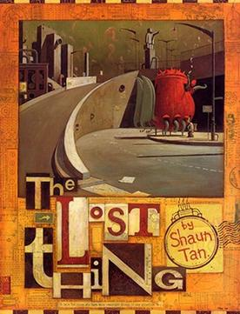

**Audience: a Year 4 child**

**Form: non-chronological report**

**Purpose: to inform**

**Revisited Skills:**

* Subordinate clauses
* Modal verbs
* Relative clauses starting who, which, where and that.
* Proofread for spelling and punctuation errors

**New Skills:**

* Modal verbs – might, should, will, must
* Instructional writing using modal verbs
* Placement of subordinate clauses
* Using our Year 5/6 spelling words
* Using formal language

**Themes:** belonging and equality

**Related texts:**

Pig Heart Boy

Lost & Found

Hidden Figures

**Tier 3 Vocabulary:**

inequality tolerance

belonging acceptance

friendship

responsibility

differences

**Tier 2 Vocabulary:**

unconscious curious

profound tirelessly

abandoned unique

dilemma

intrigued