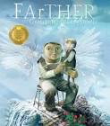 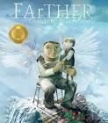

**Tier 2 Vocabulary:**

**century experiment extreme**

**Imagination knowledge length ordinary particular peculiar possession suppose**

**Various creating trial design**

**Revisited Skills:**

* To explore and make predictions.
* To use fronted adverbials to add detail to information
* To plan for a narrative by logically sequencing events
* To sustain description within writing using carefully selected vocabulary

**New Skills:**

* To select appropriate vocabulary to show character emotion
* To clarify meaning by using extended sentence structures

**Audience: The Grandson’s child.**

**Form: First person narrative**

**Purpose: To entertain**

**Tier 3 Vocabulary:**

**adjustments invention/ inventor prototype ambition/ambitious**

**Theme:** Innovation and invention

**Related texts:**

Once Upon a Big Idea **–** *James Carter*

Until I Met Dudley Roger*- Chris Riddell*

The Story of Flight -*Jakob Whitfield*

Skygazing - *Anna Claybourne*