Year 6 Design and Technology – Construction with Electrics – Doodlers
What should I already know? | What am I going to learn in this unit? | Vocabulary I need to know
Textiles  - I can give examples of how different designers and brands have upcycled items of clothing.  - I can create different designs that use the materials I have been given.  - I can use exploded diagrams to show different levels of detail with my design.  - I can select or reuse a fastening for a purpose.  - I can create a paper prototype of my design to turn into pattern pieces.  - I can accurately cut my pattern pieces.  - I can use a range of appropriate stitches to hold my design together securely.  - I can add decorative detail to make my product appealing.  - I can evaluate my product for purpose and visual appeal. | - I can analyse a product to work out how the different components work to make the product work.  - I can name and explain how an electrical circuit works within a product.  - I can explain how to ensure an electrical circuit is used safely in a product.  - I can use an exploded diagram to explain how a product works.  - I can explain which parts of a product affects its function.  - I can explain who this product’s target user might be.  - I can assemble a product and decide how best to make it.  - I can create instructions about how to make a product for someone else to follow.  - I can alter the way a product functions by tinkering with its configuration.  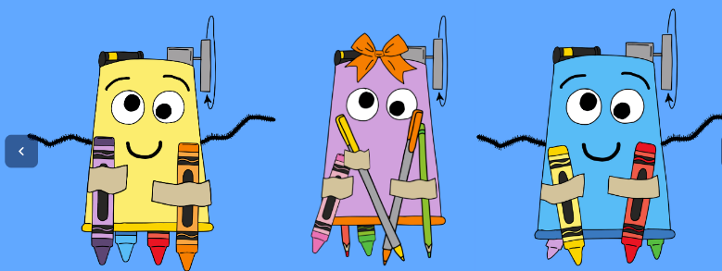 | Appealing Making something look attractive and exciting.  Axle Allows something to spin on a point. Like in an electric fan  Component The different parts that are needed to create something.  Target User The people or animals that a product has been designed for. E.g Children aged 7-9  Alter Change something or part of something  Functionality What a product does and whether it does what it is supposed to.  Analyse When you study something to see what you can learn from it.  Configuration How things are put together and relate to each other so they meet their purpose.

