Use parental controls on your child's iPhone, iPad and iPod touch
With Content & Privacy Restrictions in Screen Time, you can block or limit specific apps and features on your child’s device. You can also restrict the settings on your iPhone, iPad or iPod touch for explicit content, purchases and downloads, and privacy.
- Set Content & Privacy Restrictions
- Prevent iTunes & App Store purchases
- Allow built-in apps and features
- Prevent explicit content and content ratings
- Prevent web content
- Restrict Siri web search
- Restrict Game Center
- Allow changes to privacy settings
- Allow changes to other settings and features
- Make changes to health and safety features

Set Content & Privacy Restrictions
- Go to Settings and tap Screen Time.
- Tap Turn on Screen Time, then tap it again. Choose "This is My [Device]" or "This is My Child's [Device]".
  - If you're the parent or guardian on your device and want to prevent another family member from changing your settings, tap Use Screen Time Passcode to create a passcode, then re-enter the passcode to confirm. After you've confirmed your passcode you'll be asked to enter your Apple ID and password. This can be used to reset your Screen Time passcode if you forget it.
  - If you're setting up Screen Time on your child's device, follow the prompts until you get to Screen Time Passcode and enter a passcode. Re-enter the passcode to confirm. After you've confirmed your passcode you'll be asked to enter your Apple ID and password. This can be used to reset your Screen Time passcode if you forget it.
- Tap Content & Privacy Restrictions. If asked, enter your passcode, then turn on Content & Privacy Restrictions.
Make sure you choose a passcode that's different from the passcode you use to unlock your device. To change or turn off the passcode on your child's device, tap Settings > Screen Time > [your child's name]. Then tap Change Screen Time Passcode or Turn Off Screen Time Passcode and authenticate the change with Face ID, Touch ID or your device passcode.
Find out what to do if you've forgotten your Screen Time passcode
With iOS 16 or later, while you’re setting up Screen Time for a child’s device, you can set age-related restrictions for content in apps, books, TV programmes and films. Just follow the onscreen instructions during the setup process.

Prevent iTunes & App Store purchases
You can also prevent your child from being able to install or delete apps, make in-app purchases and more. To prevent iTunes & App Store purchases or downloads:
- Go to Settings and tap Screen Time.
- Tap Content & Privacy Restrictions. If asked, enter your passcode.
- Tap iTunes & App Store Purchases.
- Choose a setting and set to Don't Allow.
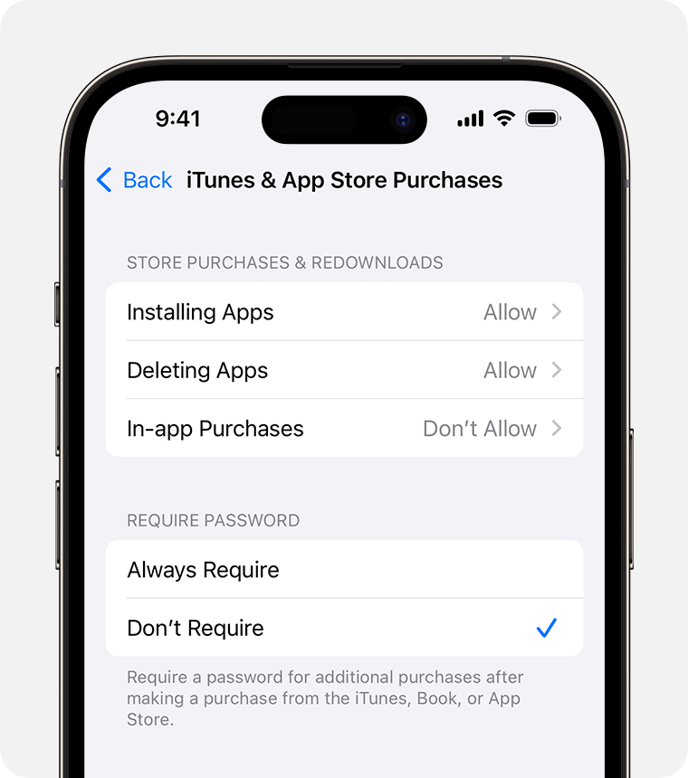
You can also change your password settings for additional purchases from the iTunes & App Store or Book Store. Follow steps 1–3, then choose Always Require or Don't Require.

Allow built-in apps and features
You can restrict the use of built-in apps or features. If you turn off an app or feature, the app or feature won't be deleted, it will just be hidden from your Home Screen temporarily. For example, if you turn off Mail, the Mail app won't appear on your Home Screen until you turn it back on.
To change your Allowed Apps:
- Go to Settings and tap Screen Time.
- Tap Content & Privacy Restrictions.
- Enter your Screen Time passcode.
- Tap Allowed Apps.
- Select the apps you want to allow.
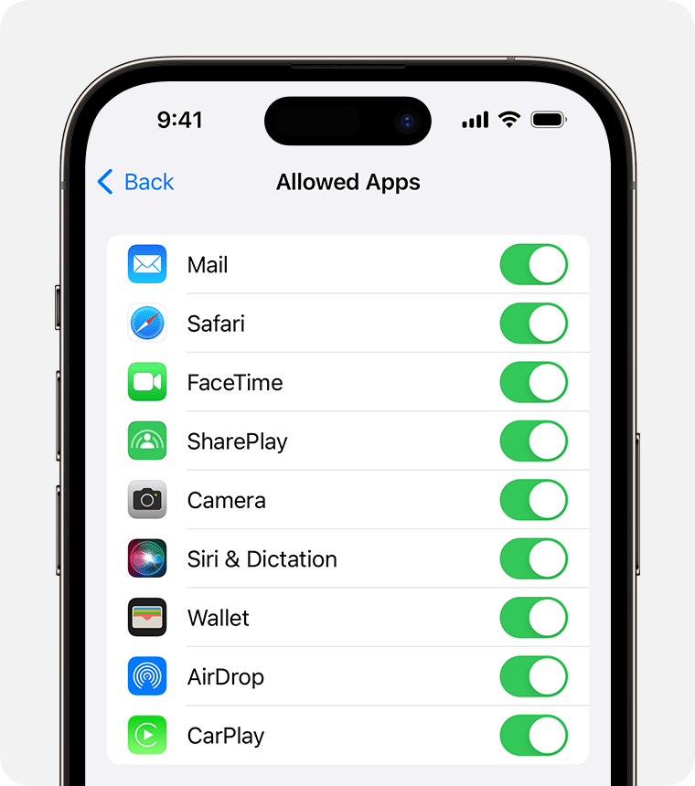

Prevent explicit content and content ratings
You can also prevent the playback of music with explicit content and films or TV programmes with specific ratings. Apps also have ratings that can be configured using content restrictions.
To restrict explicit content and content ratings:
- Go to Settings and tap Screen Time.
- Tap Content & Privacy Restrictions, then tap Content Restrictions.
- Choose the settings you want for each feature or setting under Allowed Store Content.
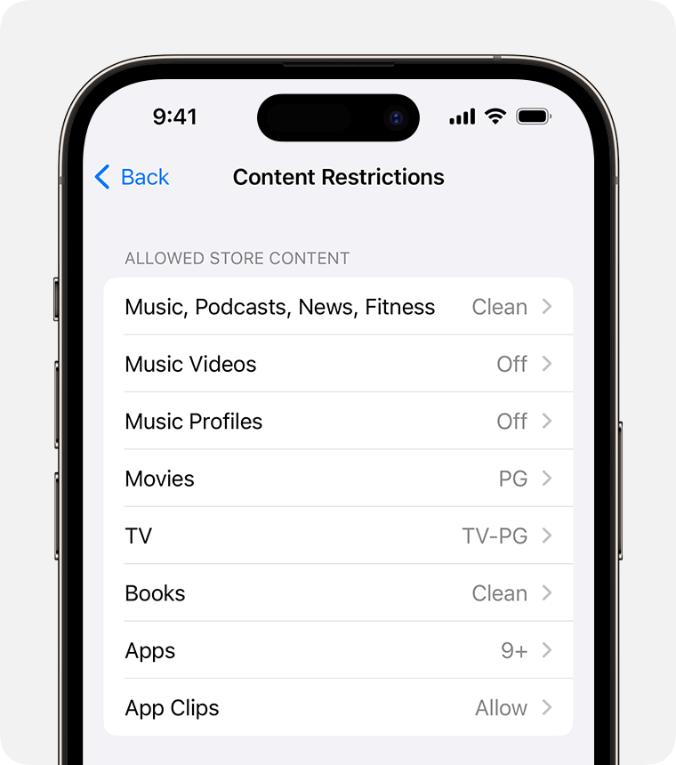
Here are the types of content you can restrict:
- Music, Podcasts, News, Fitness: prevent the playback of music, music videos, podcasts, news and workouts containing explicit content
- Music Videos: prevent finding and viewing music videos
- Music Profiles: prevent sharing what you're listening to with friends and seeing what they're listening to
- Films: prevent films with specific ratings
- TV Programmes: prevent TV programmes with specific ratings
- Books: Prevent content with specific ratings
- Apps: Prevent apps with specific ratings
- App Clips: prevent app clips with specific ratings

Prevent web content
iOS and iPadOS can filter website content automatically to limit access to adult content in Safari and other apps on your device. You can also add specific websites to an approved or blocked list, or you can limit access to only approved websites. Follow these steps:
- Go to Settings and tap Screen Time.
- Tap Content & Privacy Restrictions and enter your Screen Time passcode.
- Tap Content Restrictions, then tap Web Content.
- Choose Unrestricted Access, Limit Adult Websites or Allowed Websites.
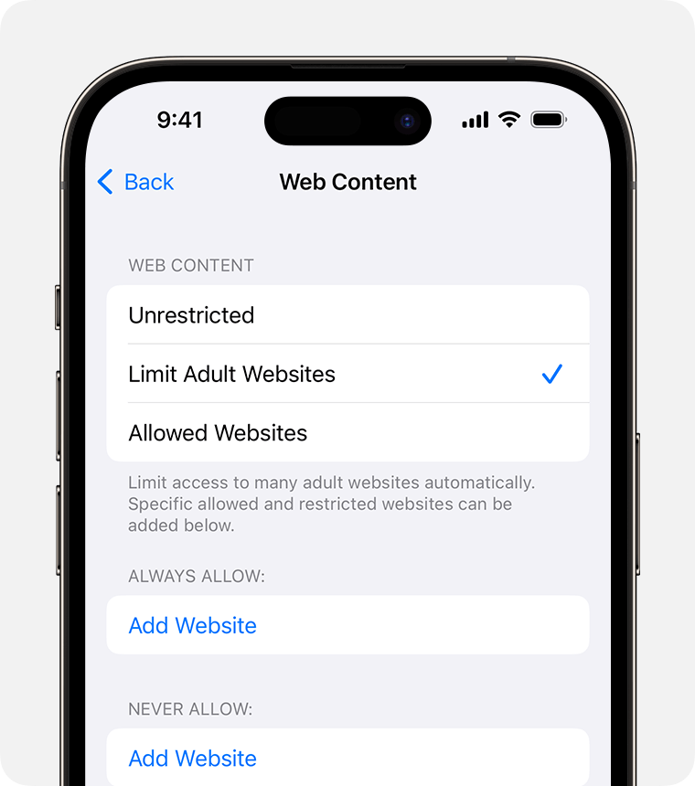
Depending on the access you allow, you may need to add information, such as the website that you want to restrict.
Each time your child updates a device signed in with their Apple ID to iOS 17, iPadOS 17, watchOS 10 or macOS Sonoma for the first time, Web Content restrictions will be reset to Limit Adult Websites for all of their devices.

Restrict Siri web search
To restrict Siri features:
- Go to Settings and tap Screen Time.
- Tap Content & Privacy Restrictions, then tap Content Restrictions.
- Scroll down to Siri, then choose your settings.
You can restrict these Siri features:
- Web Search Content: Prevent Siri from searching the web when you ask a question
- Explicit Language: Prevent Siri from displaying explicit language

Restrict Game Center
To restrict Game Center features:
- Go to Settings and tap Screen Time.
- Tap Content & Privacy Restrictions, then tap Content Restrictions.
- Scroll down to Game Center, then choose your settings.
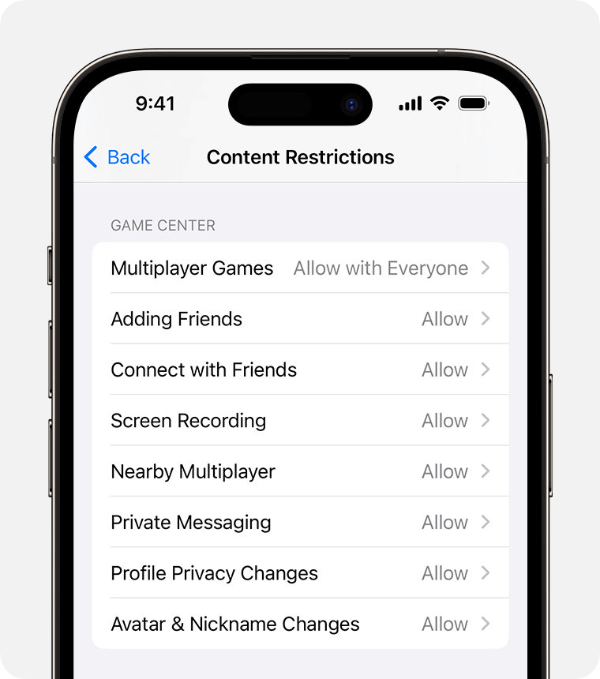
You can restrict these Game Center features:
- Multiplayer Games: prevent the ability to play multiplayer games with everyone, allow with friends only or allow with anyone
- Adding Friends: Prevent the ability to add friends to Game Center
- Connect with Friends: prevent the ability to share a Game Center friend list with third-party games
- Screen Recording: Prevent the ability to capture the screen and sound
- Nearby Multiplayer: prevent the ability to enable the nearby setting
- Private Messaging: prevent the ability to voice chat, or to send or receive custom messages with game and friend invitations
- Profile Privacy Changes: prevent the ability to change profile privacy settings
- Avatar & Nickname Changes: prevent the ability to change Game Center avatars and nicknames

Allow changes to privacy settings
The privacy settings on your device give you control over which apps have access to information stored on your device or the hardware features. For example, you can allow a social networking app to request access to use the camera, which allows you to take and upload pictures.
To allow changes to privacy settings:
- Go to Settings and tap Screen Time.
- Tap Content & Privacy Restrictions. If asked, enter your passcode.
- Under Privacy, tap the setting you want to change.
Here are the things you can restrict:
- Location Services: lock the settings to allow apps and websites to use location
- Contacts: Prevent apps from accessing your Contacts
- Calendars: Prevent apps from accessing your Calendar
- Reminders: Prevent apps from accessing your Reminders
- Photos: Prevent apps from requesting access to your photos
- Share My Location: lock the settings for location sharing in Messages and Find My Friends
- Bluetooth sharing: Prevent devices and apps from sharing data through Bluetooth
- Microphone: Prevent apps from requesting access to your microphone
- Speech Recognition: Prevent apps from accessing Speech Recognition or Dictation
- Apple Advertising: prevent changes to advertising settings
- Allow Apps to Request to Track: prevent tracking activity by apps that you've denied access to
- Media & Apple Music: Prevent apps from accessing your photos, videos or music library

Allow changes to other settings and features
You can allow changes to other settings and features, the same way you can allow changes to privacy settings.
- Go to Settings and tap Screen Time.
- Tap Content & Privacy Restrictions. If asked, enter your passcode.
- Under Allow Changes, select the features or settings you want to allow changes to and choose Allow or Don't Allow.
Here are some features and settings you can allow changes for:
- Passcode Changes: prevent changes to your passcode
- Account Changes: prevent account changes in Accounts & Passwords
- Mobile Data Changes: prevent changes to mobile data settings
- Reduce Loud Sounds: prevent changes to volume settings for safe listening
- Driving Focus: prevent changes to the Driving Focus
- TV Provider: prevent changes to TV provider settings
- Background App Activities: Prevent changes regarding whether or not apps run in the backgroun

