Year 6 – Art – Using Sketchbooks
What should I already know? | What am I going to learn in this unit? | Vocabulary I need to know
- I know how to explain the style of art used and how it has been influenced by a famous artist.  - I understand what a specific artist is trying to achieve in any given situation.  - I understand why art can be very abstract and what message the artist is trying to convey.  - I can comment on the ideas and methods of different artists, accurately using art vocabulary.  - I can experiment with a variety of media selecting these for a purpose.  - I can use the techniques of the artist, genre or culture adapting to a purpose | - I know how to experiment with media to create emotion in art.  - I know how different media can be used to convey different emotion in art  - I can use the same media in different ways to convey different feelings  - I know how to use a range of e-resources to create art.  - I can use art that is available online to create new images  - I can use digital art platforms to create art  - I can use digital images and combine these with other media to use IT to create art which includes my own work and that of others.  - I can select images to combine with my own work for a set theme  - I know how to use images created, scanned and found; altering them where necessary to create art.  - I can alter an image using online tools to use in a new piece of art | Manipulate To manipulate is to change or model by careful use of the hands; to manage shapes and forms in a space, less by additive or subtractive techniques than by moving things around.  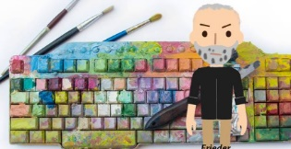 Digital Media Digital media refers to art made using software, computers, or other electronic devices. Anything produced or made on digital media, such as animations, photographs, illustrations, videos, digital paintings, and such can be classified as digital art.  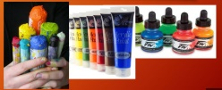 Wet Media Wet is any media that flows, or in other words, uses a liquid as pigment medium. Oil, watercolour, acrylic, and ink all fall into that category.  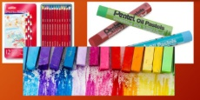 Dry Media Dry media includes but is not limited to graphite, charcoal, pastels, coloured pencils, chalk, and art crayons.  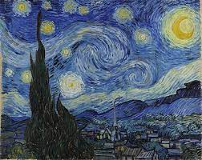 Representation Works of art that closely resemble forms in the natural world but is not a direct copy.  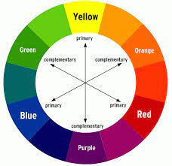 Complimentary Complementary colours are defined as colours that have maximum contrast for each other. The fundamental complementary pairs for painters are red/green, yellow/violet, and blue/orange.  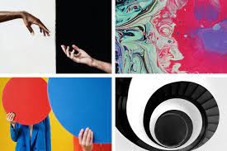 Contrasting Contrast art refers to the arrangement of opposite elements (light vs. dark colours, rough vs. smooth textures, large vs. small shapes  Symbolic Symbolist painters believed that art should reflect an emotion or idea rather than represent the natural world.  Atmosphere The way in which an artist uses colour and images in order to create as mood or feeling.

