Year 6 – Music – Drama!
What should I already know? | What am I going to learn in this unit? | Vocabulary I need to know
- I can comment on music that I am listening to using an increasing amount of musical terminology  - I know the difference between major, minor scales and modes and how each are used  - I can identify orchestral instruments and some medieval instruments  - I understand how modes were used in the Medieval and Tudor periods and are still used in music of today  - I know how to use scales and modes to compose my own pieces using a given structure  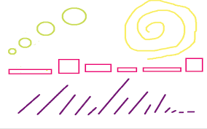 | - To describe and analyse music using a growing range of musical terminology and vocabulary  - To justify my opinions about a piece of music using musical terminology  - To understand the time / context and society that music was written and performed in  - To respond creatively to the stimulus by singing / playing or composing using voice, tuned or untuned instruments  - To compose a piece of music in ternary form with a contrasting tonality for the B section  - To understand the feature of Ostinato and can use it in my own compositions  - To play simple riffs and melodies from the music we are studying on tuned instruments  - To notate a composition using a graphic score | Articulation How the attack of a note can be changed for a dramatic effect  Staccato To play a note short and detached  Legato To play notes smoothly  Accent To accent the note and give it extra force  Tenuto To press the note with a slight emphasis  Ostinato A rhythmic or melodic pattern that is repeated over and over again  Riff A short melodic pattern that is instantly recognisable

