Year 6 – French – Les planètes – Spring 1
What should I already know? | What am I going to learn in this unit? | Vocabulary I need to know
- I know the letter sounds (phonics and phonemes) from phonics and pronunciation lessons and can use them in my French speaking  - I know the vocabulary from the Early learning and intermediate units  - I know what an adjective is in English | - I can name and spell up to eight planets in French on a solar map.  - I can say and write extended sentences for at least one planet in French.  - I understand how adjectives need to agree with the nouns they are describing in French and apply these rules in my spoken and written French to improve my grammatical accuracy. | 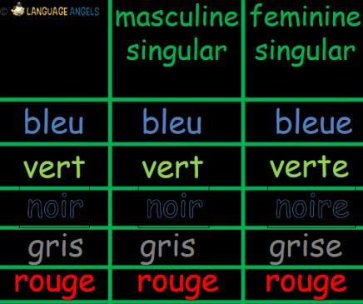  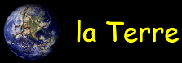  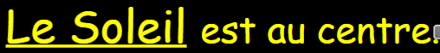  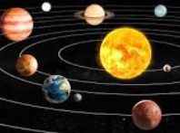  The sun is in the centre.  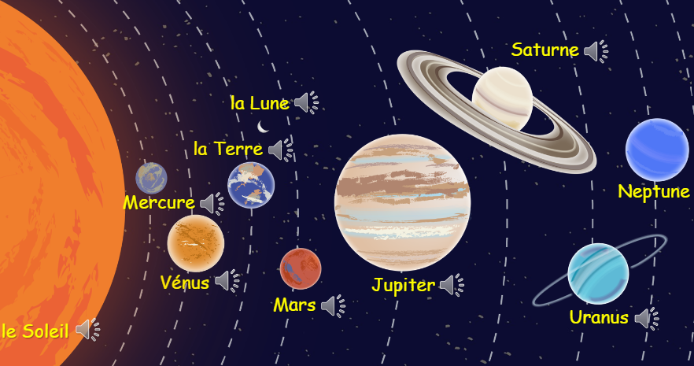  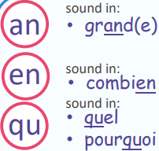  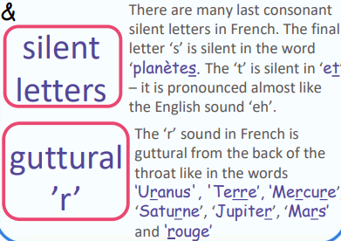  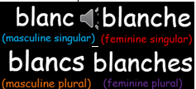  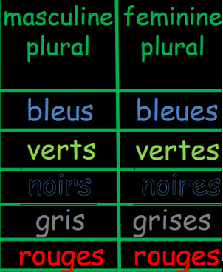  small  big  enormous  Jupiter is big.  Neptune is a blue planet.  