Year 5 – Geography – Urban Environments
What should I already know? | What am I going to learn in this unit? | Vocabulary I need to know
- I can explain the different features of a river.  - I can explain how the different features are grouped by the course of the river.  - I can recognise the key events that contribute to river flooding.  - I can identify the impacts that flooding has upon local people living and working in an area.  - I can understand how to read an OS map identifying the key, scale and contour lines.  - I can identify up to 6 digit grid references for locations on a map.  - I can use my knowledge of rivers to identify the location of pictures where they fit within a river course.  - I can explain how waterfalls are formed.  - I can create a model of a waterfall and label each part of the waterfall.  - I can use scientific equipment to record measurements of rivers including velocity, depth and width. | - I can use different tools including maps and globes to locate the equator and the tropics of Cancer and Capricorn.  - I know the names of and can locate several countries in South America and North America.  - I can explain the link between physical and human geography when it comes to human settlements.  - I can explain differences between the urban populations in North and South America  - I can give examples of different human geographical features such as population, economy, and life expectancy.  - I can explain how a slum develops and give examples of what living there might be like.  - I can give reasons why people live in slums.  - I can explain similarities and differences between two urban environments with high levels of poverty.  - I can give examples of the challenges faced by people living in slums.  - I can explain why there are more people living in slums in South America than North America. | Slums 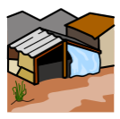 An informal, densely populated and usually illegal settlement that is inhabited (lived in) by the urban poor  Services A system provided for people, such as transport, education, internet, electricity.  Urbanisation 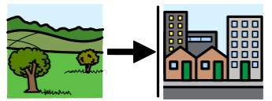 The process whereby an increasing proportion of people live in towns and cities.  Migration 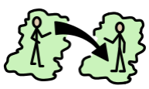 The movement of people (or animals) from one place to another.  Inhabitant 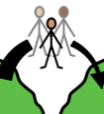 A person who lives in an area.  Inequality 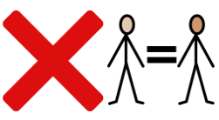 Difference or inconsistency  Quality of life The level of overall wellbeing of an individual, community or a country. It is made up of many factors, including wealth, health, rights and education.  Standard of living The level of wealth and material goods that an individual, community or country has access to. This is a numerical value, usually measured in US dollars.

