Year 5 – Design and Technology – Super Seasonal Cooking
What should I already know? | What am I going to learn in this unit? | Vocabulary I need to know
- I know that imported foods travel from far away and this can negatively impact the environment.  - I can bring a creative element to the food being designed.  - I can follow a recipe to make a food product.  - I can weigh out food items.  - I can work within a budget to plan a meal.  - I know which seasons different foods are ready for harvesting. | - I can explain what is meant by seasonality and give examples of different fruit and vegetables that are in season in the UK.  - I can name some foods which are grown, reared, caught and processed in the UK.  - I can give examples of dishes that can be cooked seasonally and use their recipes as inspiration.  - I can generate a range of ideas for balanced seasonal soup recipes.  - I can develop and refine a recipe.  - I can chop and prepare different vegetables.  - I can explain what is meant by seasoning food and have experimented with using different seasonings.  - I can use mixers appropriately and safely.  - I can safely use a hob and manage hot pans.  - I can evaluate a range of products based on taste, appearance, texture and smell. | Seasonal or Seasonality 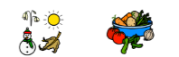 Which foods are ready to eat during different seasons (Spring, Summer, Autumn and Winter). We’re focusing on seasonal British food.  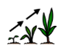 Grown Food like fruits and vegetables which grow and are harvested.  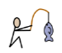 Caught Food that is caught such as fish.  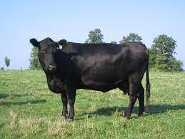 Reared Food such as cows, chicken or sheep that are looked after then killed for meat.  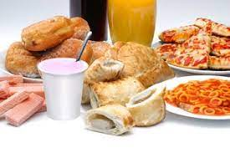 Processed Food that has been changed while being prepared. The most common processed foods include bread and cheese. Some processed foods are unhealthy.  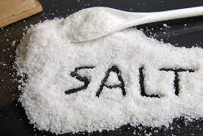 Preservatives Things like salt or chemicals that are added to food to make it last longer.  