Year 5 Computing Spring 1
What should I already know? | What am I going to learn in this unit? | Vocabulary I need to know
- I know the purpose of programming  - I know when using the internet my usage can be monitored  - I know that unacceptable behaviour can be traced  - I know that computers use keyboards to input text  - I know that a word document can be used to type words  - I know that I can use tools to edit my typing  - I know I can include repetition and loops in programming using text commands  - I know I can identify and debug problems in an algorithm  - I know I can predict and explain an outcome of an algorithm  - I know I can demonstrate acceptable behaviour when using the internet  - I know I can edit my typing to adjust text size for a specific reason  - I know I can use home keys for typing to improve my speed and accuracy | Digital Literacy:  - I can use a search engine to search for someone online  - I can collate information about someone from information found online  - I know that information found online about someone may not always be true  - I know that information found about someone online may lead to inaccurate judgements being made  Information Technology:  - I know how search engines work  - I know that search engines rank information they provide  - I can explain how information is ranked that a search engine provides  - I know what biased means  - I know that not all digital content is reliable  - I can determine what digital content is reliable  Computer Science:  - I know what a condition block is  - I can write an algorithm using ‘if…then…else’  - I can debug an algorithm to develop my programme | search engine special websites that make it easy for you to find a website or page in an instant  collate to gather together information from different sources in order to study it carefully  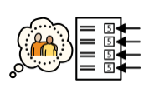 reliable capable of being trusted or relied on; dependable.  selection used to make choices depending on the information  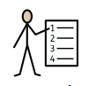 algorithm a sequence of instructions that are followed to complete a task  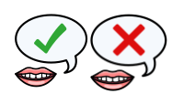 condition the state of something in the program that's true or false  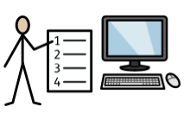 program a defined set of algorithms or processes that are completed in order to achieve a task  debug when you find an issue in the program that you have written and repair it

