Year 5 – Music Spring 1 Chrome Music Lab
What should I already know? | What am I going to learn in this unit? | Vocabulary I need to know
- I can describe and analyse music using a growing range of musical terminology  - I understand the way accidentals can affect the tonality of a piece of music  - I can use a non-Western scale to compose and improvise music  - I can play a range of tuned and untuned instruments  - I can compose using a stimulus and given keys to create a structured composition evoking a specific mood or atmosphere | - I can sing rounds and partner songs  - I understand the origins and history of music made by computers and using technology  - I can improvise over a simple groove responding to beat and creating a satisfying melodic shape  - I can use chords to compose music to evoke a specific atmosphere, mood or environment  - I can create music to accompany a silent film or to set a scene  - I can capture and record creative ideas using music technology | Music Technology 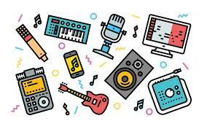 Using computers or other computerised sound to create or record music  Sequence 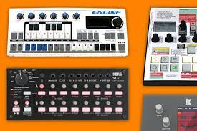 To input a piece of music bit by bit into a computer programme to create a whole piece  Spectrogram 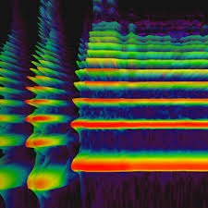 A picture of a sound and how each picture varies according to pitch and kind of sound being produced  Attack and Decay 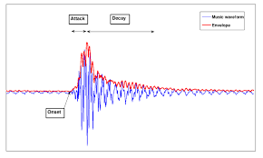 How the beginning of a sound starts and how it ends for example is it sudden or gradual?  Manipulation How we can use music technology to change the sound of the music we have recorded by adding effects  Synaesthesia 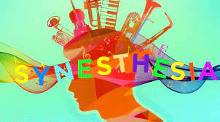 A condition that some people have which means they see colours when they hear notes played  Graphic Score 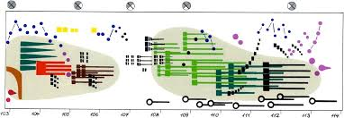 A way of notating music using pictures and symbols rather than regular music notation

