Year 5 Science – Living Things (Life Cycles) - Spring 1
What should I already know? | What am I going to learn in this unit? | Vocabulary I need to know
- Explore and compare the differences between things that are living, dead, and things that have never been alive  - Identify that most living things live in habitats to which they are suited and describe how different habitats provide for the basic needs of different kinds of animals and plants, and how they depend on each other.  - Identify and name a variety of plants and animals in their habitats, including microhabitats.  - Recognise that living things can be grouped in a variety of ways.  - Explore and use classification keys to help group, identify and name a variety of living things in their local and wider environment.  - Recognise that environments can change and that this can sometimes pose dangers to living things | - I can understand the life cycle of different living things including mammals, amphibians and insects.  - I can understand the similarities and differences between these life cycles.  - I can understand the process of reproduction in animals.  - I can understand the process of reproduction in plants.  - I can research animal behaviourists and naturalists  - I can understand the difference between sexual and asexual reproduction in plants  - I can understand the term sexual reproduction in animals  - ‘I can observe and compare the life cycle of plants and animals  - I can record information using scientific diagrams and labels  - I can sort scientific evidence that has been used to support or refute ideas. | Mammal  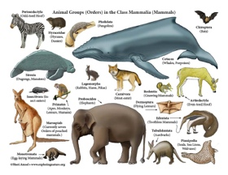 | A warm-blooded vertebrate animal
 |  | Amphibian  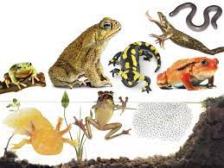 | A cold-blooded vertebrate animal.
 |  | Reproduction  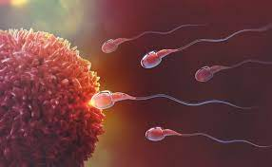 | A process where a living thing reproduce offspring who are similar.
 |  | Classification  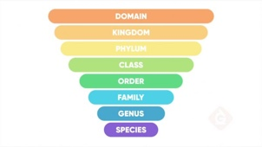 | A category into which something is put.
 |  | Characteristics  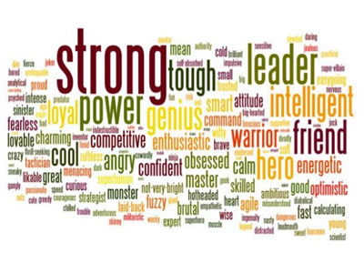 | A feature or quality belonging typically to a person, place, or thing and serving to identify them.

