Year 4 – History – Vikings: Raiders or Traders?
What should I already know? | What am I going to learn in this unit? | Vocabulary I need to know
- I can explain when the Romans left Britain and give an example of other Empires across the world.  - I know where different Saxons (Angles, Saxons, Jutes) came from and why they came to England.  - I can list some push/pull reasons for the Saxon invaders and settlements.  - I can name the different peoples, where they came from and where they settled.  - I can name the 7 Saxon Kingdoms.  - I can talk about the legacy of the Saxons.  - I can give examples of what life was like in Saxon Britain.  - I can interpret different sources and say what it teaches us about Saxon Britain.  - I can explain what causes and consequences I think are the most important during the Saxon time period.  - I can sequence key events in chronological order. | - I know that the Vikings first came to Britain in 793 AD and settled in 850AD.  - I know that the original meaning of the word Viking was raider or looter.  - I can explain where the Vikings fit into Britain’s timeline.  - I know that the Vikings were from Scandinavia which is now known as Norway, Sweden and Denmark.  - I can give examples of what the Vikings traded around the world.  - I know that Vikings used longboats to travel long distances.  - I can explain why the Vikings came to Britain and why this was significant.  - I can give reasons why the Vikings wanted to stay in Britain.  - I can give examples of artefacts that have been found in Britain that tell us about how the Vikings lived.  - I can give examples of what was similar and what was different between the Viking and Saxon raids. | Similarities 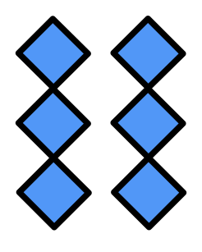 It means the same or very like something else.  Differences 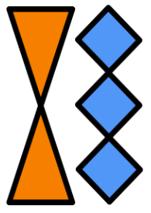 It means not the same as something else.  Scandinavia In 2023 we call this area Norway, Sweden and Denmark.  Trade 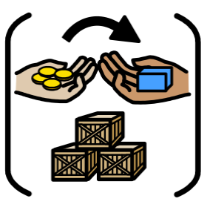 Where people or countries sell or swap things they have discovered, grown or made.  Raid 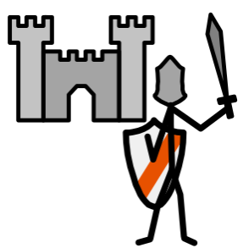 A sudden attack where things are taken or broken.  Settlements 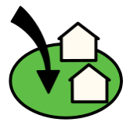 Where people create new places to live like villages.  Chronology 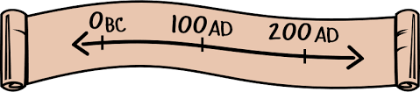 In time order  Legacy Values, rules and influences that are left from someone or a group of people.

