Year 4 Science - Living things and their habitats– Spring 1
What should I already know? | What am I going to learn in this unit? | Vocabulary I need to know
- Identify and name a variety of common animals including fish, amphibians, reptiles, birds and mammals.  - Identify that most living things live in habitats to which they are suited and describe how different habitats provide for the basic needs of different kinds of animals and plants, and how they depend on each other.  - Identify and name a variety of plants and animals in their habitats, including microhabitats.  - Describe how animals obtain their food from plants and other animals, using the idea of a simple food chain, and identify and name different sources of food.  - Notice that animals, including humans, have offspring which grow into adults.  - Comparing the differences between things that are living, dead, and things that have never been alive  - Identify a variety of plants and animals in their habitats | - I can recognise that living things can be grouped in a variety of ways  - I can explore and use classification keys to help group, identify and name a variety of living things in their local and wider environment  - I can recognise that environments can change and that this can sometimes pose dangers to living things  - I can explore possible ways of grouping a wide selection of living things that include animals, flowering plants, and non-flowering plants  - I can research examples of human impact (both positive and negative) on environments  - I can make and answer questions based upon my observations of animals. | Classify  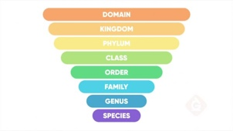 | Sorting people/things according to a chosen criteria
 |  | Habitat  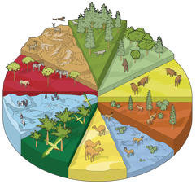 | The natural home or environment of an animal, plant or other organism
 |  | Classification Key  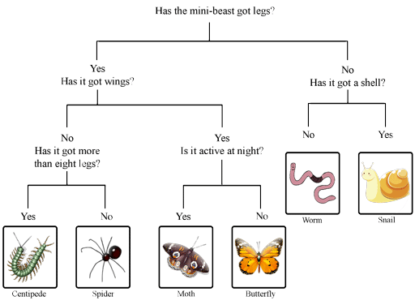 | A set of questions about the characteristics of living things.
 |  | Vertebrate  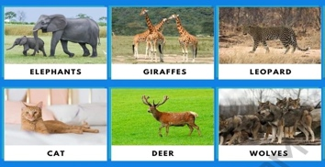 | An animal that does have a backbone.
 |  | Invertebrate | An animal that does not have a backbone.
 |  | Environment | The air, water, and land in/on which people, animals and plants live.

