Year 4 – French – Boucle d’Or et les trois ours – Spring 1
What should I already know? | What am I going to learn in this unit? | Vocabulary I need to know
- I can ask and answer the questions, ‘What is your name?’, ‘How old are you?’ and ‘Where do you live?’ in French  - I can ask someone’s nationality in French and can use the masculine and feminine forms for adjectives describing nationality  - I know the nouns for family members in French  - I can say, read and write the numbers from one to seventy in French  - I can read, write and understand simple sentences describing name, age, place of residence and nationailty in French  - I can use masculine, feminine and plural possessive pronouns in French (‘my’ form only) | - I can say and recognise nouns for key items in the story ‘Goldilocks and the three bears’ in French  - I can say ‘Once upon a time…’ in French  - I can read and write simple sentences and phrases from the story  - I can listen attentively to a whole familiar fairy tale in French (listening out for key words and repeated language)  - I am developing my gist reading and listening skills (looking and listening out for key words)  - I can attempt to retell a familiar fairy tale in French using a mini book for support | 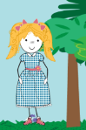  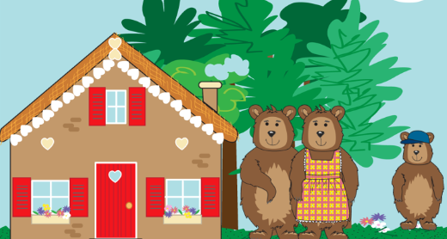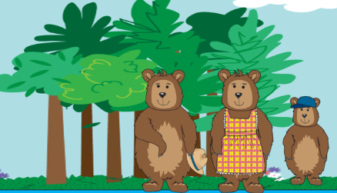  Il était une fois une famille d’ours … …une bonne soupe… une promenade dans la forêt Boucle d’Or  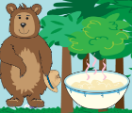  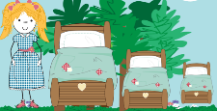  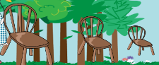  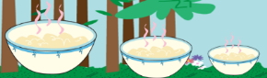  le grand/moyen/petit bol la grande/moyenne/petite chaise le grand/moyen/petit lit ‘Quelqu’un a touché ma soupe  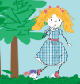  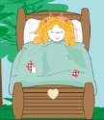  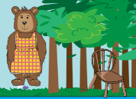  ‘Quelqu’un a touché ma chaise’ ‘Quelqu’un a touché mon lit et elle est toujours là’ Boucle d’Or a couru en dehors.  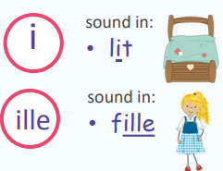  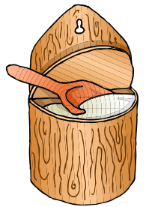  trop sucré trop sale une maison  THE END  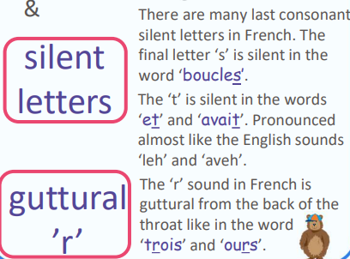  LA FIN

