Year 3 – Music Spring 1 Recorder
What should I already know? | What am I going to learn in this unit? | Vocabulary I need to know
- I can sing tunefully and with expression  - I understand the difference between a crotchet a paired quaver and a crotchet rest  - I know the basic elements of music like dynamics and tempo  - I understand how notation works pitch-wise on a stave and have been introduced to the notes C, D and E  - I have developed a skill on a tuned percussion instrument and know how to play a simple melody in time and with good technique | - I can sing a widening range of unison songs of varying styles  - I can play the recorder and play melodies following staff notation  - I can use my listening skills to correctly order phrases using dot notation  - I can copy stepwise melodic phrases with accuracy at different speeds  - I understand the stave, lines and spaces and clef  - I understand the differences between crotchets, paired quavers and crotchet rests  - I can listen to a piece of music and understand the tradition and historical context of the music we are listening to | Recorder 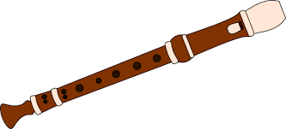 A simple woodwind instrument that changes notes by applying fingers to holes  Woodwind instruments 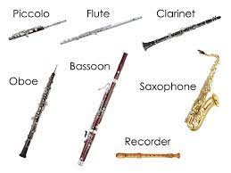 Instruments of the orchestra that are blown into and were originally made of wood (although some materials have changed now)  Stave 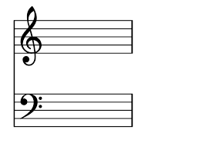 The five lines that music is written on  Note B, A and G 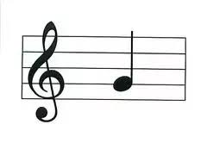 Our first three notes on the treble clef stave that we are learning on the recorder  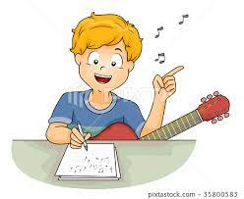 Compose To write a piece of music or melody that sounds nice  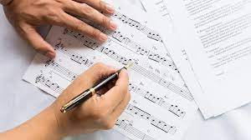 Notate To write our melody down on a stave so that others can play it and we can remember it  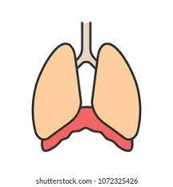 Diaphragm The muscle between the lower part of our ribs that controls our breathing

