Year 3 – Geography – Mountain and the water cycle
What should I already know? | What am I going to learn in this unit? | Vocabulary I need to know
- I can name and map the geographical regions of the UK and where I live.  - I can name and locate the cities near where I live and explain what a city is.  - I can name and locate the counties near where I live and explain what a county is  - I can use and interpret maps and atlases of the United Kingdom to identify local cities and counties.  - I know that I live in the city of Southampton  - I can explain what we mean by settlement and how land use influences settlements.  - I know the 4 settlement types – city, town, hamlet and village  - I know that Southampton is made up of different suburbs and our school is in Bitterne  - I can name similarities and differences between Hamble and Bitterne  - I can gather, record and classify information in a variety of ways to help answer questions  - I can present findings selecting tables, charts and graphs and make observations | - I know what the difference between a mountain and a hill is.  - I know what the three highest mountain ranges are in the UK.  - I know what the summit, face, ridge and valley are.  - I can explain the structure of the Earth.  - I know that some mountains are formed from tectonic activity.  - I know that tectonic plates move in different directions.  - I can explain what the climate is like in mountains.  - I know what evaporation is.  - I know what precipitation is.  - I know what condensation is.  - I know the process of the water cycle.  - I know how the water-cycle affects the world around me. | Fold 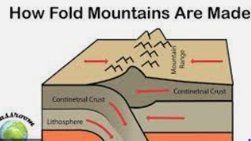  Volcanic 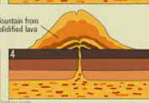  Ridge 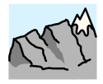 Landform that consists of a chain of mountains or hills that form lots of peaks  Summit 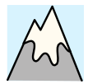 Top of a mountain or hill.  Face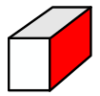 The side of a mountain.  Valley The low level ground between the base of different mountains.

