Year 3 – French – Les saisons – Spring 1
What should I already know? | What am I going to learn in this unit? | Vocabulary I need to know
- I know French is spoken in France and other countries  - I can say hello, how are you and answer the question in French  - I ask someone their name and answer the question in French  - I can say and write the numbers one to ten in French, attempting to spell them correctly  - I can name five colours in French  - I can name ten musical instruments in French  - I can use the first person of the verb ‘jouer’ (to play): je joue (I play) to say which instruments I play | - I can name, recognise and remember all four seasons in French  - I can start to recognise and use the conjunctions ‘et’ (and) and ‘car’ (because) in my spoken and written French  - I am learning to listen to French and becoming more familiar with the different phonics/ pronunciation and letter strings/phonemes  - I am developing my memory and recall skills for words in another language (French) | 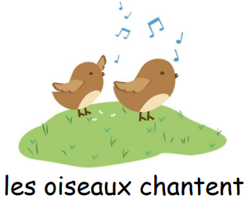  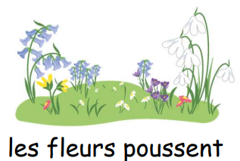  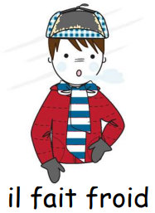  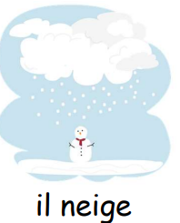  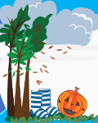  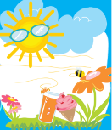  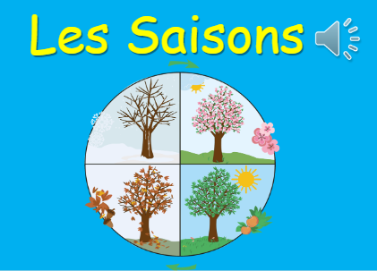  l’été  le printemps  The seasons  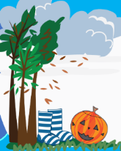  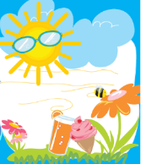  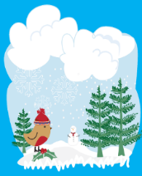  l’automne  l’hiver  