Year 3 Science – Animals (Nutrition & Skeleton/Muscles)– Spring 1
What should I already know? | What am I going to learn in this unit? | Vocabulary I need to know
- Begin to make sense of their own life-story and family’s history.  - Notice differences between people.  - Notice that animals, including humans, have offspring which grow into adults.  - Identify, name, draw and label the basic parts of the human body and say which part of the body is associated with each sense.  - Describe the importance for humans of exercise, eating the right amounts of different types of food, and hygiene. | - I can identify that animals, including humans, need the right types and amount of nutrition, and that they cannot make their own food; they get nutrition from what they eat  - I can identify that humans and some other animals have skeletons and muscles for support, protection and movement  - I can identify and group animals with and without skeletons and observe and compare their movement  - I can explore ideas about what would happen if humans did not have skeletons  - I can compare and contrast the diets of different animals  - I can research different food groups and how they keep us healthy | Nutrition  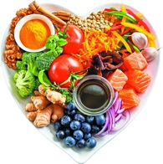 | Food or nourishment necessary for food and growth.
 |  | Skeleton  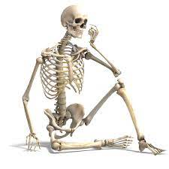 | External framework of bone, cartilage, or other rigid material supporting or containing the body of an animal or plant.
 |  | Muscles  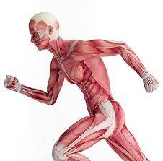 | A band or bundle of fibrous tissue in a human or animal body that can contract.
 |  | Movement  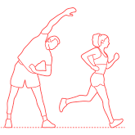 | An act of moving.
 |  | Healthy  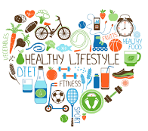 | In a good physical or mental condition.
 |  | Balanced Diet  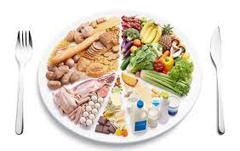 | A diet consisting of a variety of different types of food and providing adequate amounts of the nutrients necessary for good health.

