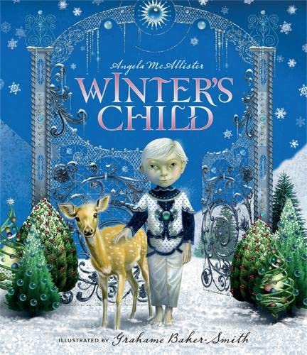

**Revisited Skills:**

* To use conjunctions to link ideas.
* To create noun phrases using: adjectives and propositions.
* To use fronted adverbials to build cohesion in my work.
* To use prepositional phrases.
* To select the correct determiner.
* To use pronouns to avoid repetition.

**New Skills:**

* To use the conventions of speech including: speech marks, reporting clause verbs.
* To effectively plan the main events of a story**.**
* To group my idea in paragraphs.

**Audience:** Winter’s Child

**Form:** Fantasy story sequel

**Purpose:** To entertain and to recount main events of a story.

**Tier 3 Vocabulary:**

* icicles - hibernate/ hibernation
* -observations – seasons
* blossom – thaw

**Tier 2 Vocabulary:**

-season - experience

- remember -consider

-believe -thought -special

-busy -extreme -environment

**Theme:** Darkness and light

**Related texts:**

**Beyond the Frozen Horizon – Nicola Penfold**

**The Frost Goblin – Abi Elphinstone & Fiona Woodcock**

**The Boy who Lost his Spark – Maggie O’Farrell**