**Audience: Tabloid audience**

**Form: Newspaper**

**Purpose: To inform**

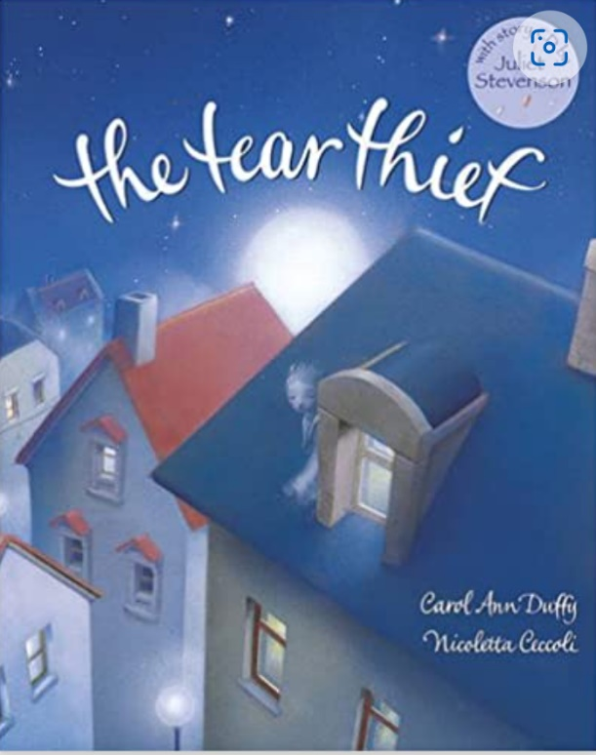

**New Skills:**

* Using present perfect form
* Fronted adverbials (with commas)
* Using the possessive apostrophe

**Revisited Skills:**

* Direct and reported speech
* Extending sentences with conjunctions
* Use a/an to introduce a noun

**Tier 3 Vocabulary:**

Tear ducts, detectives, police officers, evidence, tabloid, broadsheet, journalist, quotation, evidence

**Tier 2 Vocabulary:**

reported, stolen, theft, fairy-like, emotions, emotional, tears, imaginary, mysterious, night-time, rooftops

**Theme:** Dreams and Desires

**Related texts:**

BFG, The Princess’ Blankets by Carol Ann Duffy, The Lost Happy Endings by Carol Ann Duffy, New and collected poems for children by Carol Ann Duffy, Happy by Nicola Edwards