Year 4 – RE- Ritual- Christianity
What should I already know? | What am I going to learn in this unit? | Vocabulary I need to know
Knowledge  - Know the concept of ‘Holy’- some of examples of rituals are seen in the Hail Mary Prayer (year 4).  - Know the meaning of the concept of ‘Ceremony’ (year 3).  Awareness of the idea of routines in their own lives.  Skills  - I can give an example of how different people show that religion is important to them.  - I can identify some difference the concept makes to the lives of religious people and myself. | Inquire  - I can describe the concept of ritual and how this is common to all people.  - I can identify and provide an example of how ritual is different to a routine.  Contextualise  - I can give examples of how Christian’s remember the resurrection of Jesus through the ritual of the Paschal candle.  - I can understand the importance of the concept of ritual to a Christian and begin to express its importance to me.  Evaluate  - I can recognise and describe accurately why the Paschal ritual is important to Christians.  - I can express my own views of the importance of rituals to Christians and explain my answer with an example.  Communicate  - I can give an example of what I would consider to be important in my life and plan a ritual around it.  - I can give opinions as to what I think makes something important enough to become a ritual and explain why.  Apply  - I can describe simple examples of how my response to the concept of ritual relates to their own lives and those of others.  - I can identify some differences the concept of ritual makes to the lives of religious people and myself. | Forgiveness 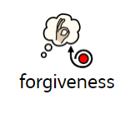 The action or process of forgiving or being forgiven.  Paschal Candle 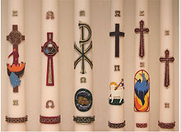 The Paschal candle is the first candle to be lit with a flame from this sacred fire, representing the light of Christ coming into the world.  Resurrection 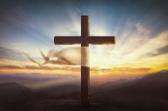 The act of coming back to life after death.  Traditions 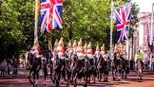 The transmission of customs or beliefs from generation to generation, or the fact of being passed on in this way.  Ceremony 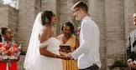 A formal religious or public occasion, especially one celebrating a particular event, achievement, or anniversary.  Eucharist A ceremony to remember the sacrifice of Jesus’ death on the cross.

