Year 6 – RE- Power- Christianity and Islam
What should I already know? | What am I going to learn in this unit? | Vocabulary I need to know
- I can explain what the concept of Holy means (year 4) and how this links to the concept of Power.  - I can recall some key Christian stories (Adam and Eve (year 4), Christmas Story and the Eater Story.  - I can recall some key facts related to the Islamic faith (year 5).  - I am able to give some examples as to how justice (year 5) links to the concept of power.  - I can give examples of how different people show that religion is important to them. | Inquire  - I can Identify that the concept of power may mean different things to different people.  - I can identify that others may have a different understanding of the concept of power and explain whether I agree and why.  Contextualise  - I can identify the ways in which God’s power is significant for Christian’s and give examples of how this is shown in religious literature/ scripture.  - I can identify the ways in which Allah’s power is significant for Muslims and give examples of how this is shown in religious literature/ scripture.  - I can draw comparisons between the concept of power within the Christian religion and the Muslim religion.  Evaluate  - I can evaluate by explain the significance of a believers’ interpretation of God’s power.  - I can explain how Christians and Muslims understanding of God’s/ Allah’s power can influence their faith.  Communicate  - I can pose questions to explore the inconsistences/ issues I identify with seeing God/ Allah as all powerful.  - I can share my own views of the concept of power giving reasons and examples for my viewpoint.  - I can explain my ideas about the value of power in my life or my ‘vision of life’.  Apply  - I can explain, justify and provide examples as to why the concept of power is important in my own life and the lives of others. | Creation 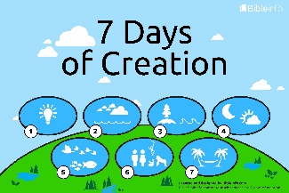 The action or process of bringing something into existence.  Influence The ability to have an effect on the character, development or actions of someone or something  The Qur’an 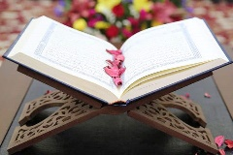 The Qur'an, sometimes spelled Koran, is the holy book of Islam. The Qur'an is considered by Muslims to be "The Word of Allah (God)".  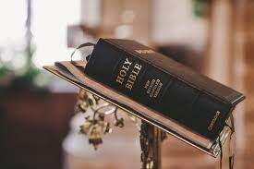 Bible The book of sacred writings accepted by Christians as coming from God.  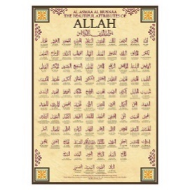 99 Names of Allah Allah (God) has many different descriptions and it is hard to represent him in a few words, so the Qur'an teaches that Allah has 99 names

