Year 3 – DT- Nets with a 3D product
What should I already know? | What am I going to learn in this unit? | Vocabulary I need to know
- I can identify different mechanisms such as flaps, sliders and levers in different contexts.  - I can analyse a variety of products which have levers and linking mechanisms.  - I can use experimenting to help me develop my ideas and create a final design.  - I can explain what a prototype is and why they are useful.  - I can explain my choices of materials.  - I can communicate what my idea is and explain how it will work to another person.  - I can order the steps I need to make my final product.  - I can select and use appropriate tools with accuracy including cutting, shaping and joining.  - I can demonstrate how to use finishing techniques to make my final product look exciting.  - I can evaluate my product for its appearance, durability and whether it is easy to use. | - I can use different techniques to cut and join paper and card.  - I can explain the properties of different 2D and 3D shapes.  - I can investigate and evaluate a range of different shell products.  - I can generate ideas to create a product that meets set criteria.  - I can analyse existing products for their effectiveness.  - I can create a design using annotated sketches on Microsoft Word to communicate my ideas.  - I can order the steps to make my product.  - I can use appropriate tools to measure, mark, cut, score and assemble my product.  - I can use Microsoft Word to create finishing products for my design.  - I can test and evaluate my product based on the design criteria. | C.A.D or Computer Aided Design 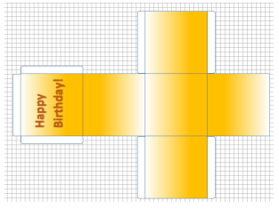 This is when you use a computer to put together ideas for a product.  2D Shapes 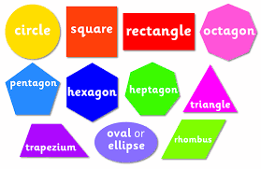 3D Shapes 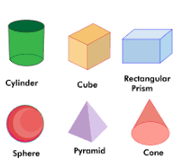  Analyse To look at something in detail and decide if it does what it is supposed to.  Shell products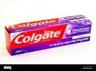 An object or thing which is covered all around but is empty inside.  Scoring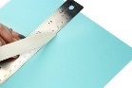 When you use a ruler and something sharp to help bend card but not cut it.  Design Putting together your ideas into a drawing or diagram.  Assemble 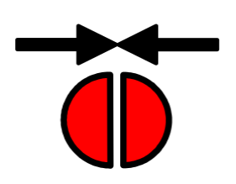 To put all the pieces together.  Design Criteria What you need to include in your final work.  Product 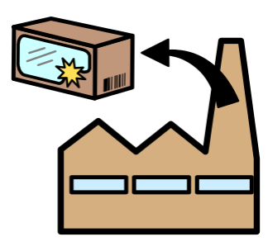 The item or object you are making.

