Year 4 – PSHE – Spring one
What should I already know? | What am I going to learn in this unit? | Vocabulary I need to know
Relationships:  - I can explain how knowing someone online is different from knowing someone face to face.  - I can identify risks in communicating with someone I don’t know.  - I can identify ways to communicate respectfully.  - I can explain what to do if I am worried about any contact online.  - I can identify the difference between playful teasing, hurtful behaviour, and bullying, including online.  - I can explain how to respond if I see or experience hurtful behaviour or bullying, including online.  Living in the wider world:  - I can explain what a community is.  - I can identify a community I belong to.  - I can identify how a community can be strong.  Health and wellbeing:  - I can explain how to brush and floss my teeth correctly.  - I can explain the importance of regular visits to the dentist.  - I can explain the effects of different foods and drinks on dental health. | Relationships:  - I can explain what confidentiality is.  - I can identify when it is right to keep or break a confidence or share a secret.  Living in the wider world:  - I can define what democracy is.  - I can identify where I see democracy at school.  - I can explain what parliament is.  - I can explain my right to vote when I am older.  - I can identify different ways to keep myself safe near railways.  - I can identify hazards at a railway.  Health and wellbeing:  - I can explain what a medicine does and why it is important to take medicines correctly.  - I can explain what is meant by a ‘household product’ and explain why it is important to use a household product correctly. | Confidentiality | Private information kept secret
 |  | 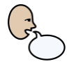  Report | To tell someone about something that has been seen or heard
 |  | 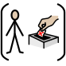  Democracy | Where people are able to choose their government by voting for it
 |  | 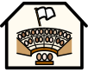  Parliament | The group of elected representatives
 |  | 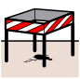  Hazard | Something which has the potential to cause harm
 |  | 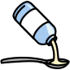  Medicine | Treatment for illness or injury
 |  | 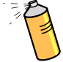  Household product | Items used in and around the house.

